**VERBAL ABILITY**



**HSEM2BTECHSTANDARDVA1119**

 **PARTS OF SPEECH**

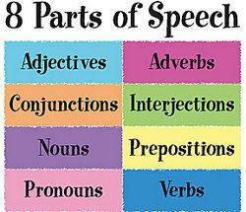

There are eight parts of speech in the English language: noun, pronoun, verb, adjective, adverb, preposition, conjunction, and interjection. The part of speech indicates how the word functions in meaning as well as grammatically within the sentence. An individual word can function as more than one part of speech when used in different circumstances.

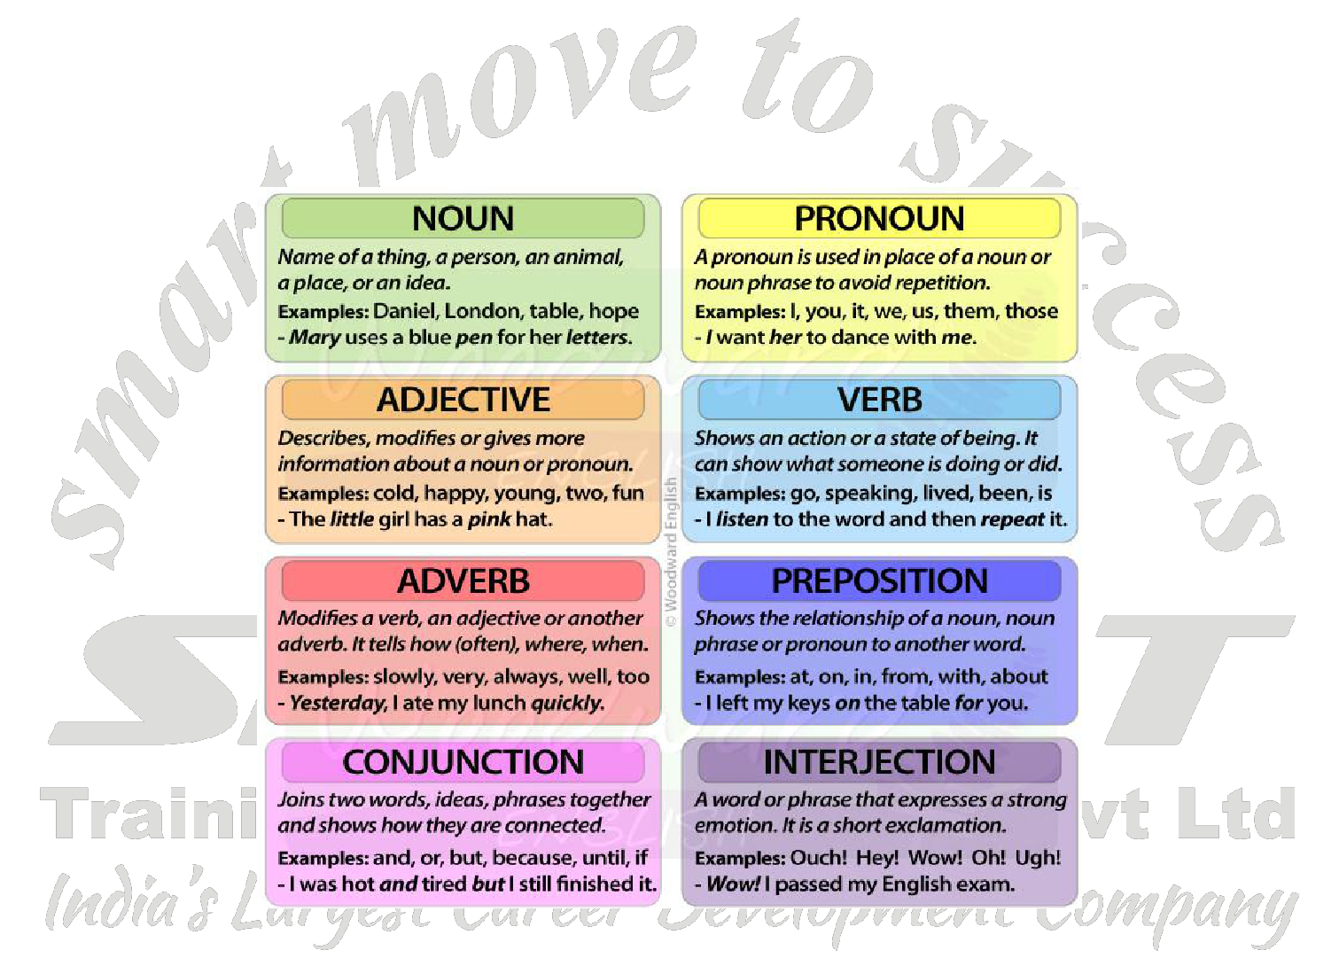

**Parts of speech**

1. **NOUN**

* **A noun is the name of a person, place, thing, or idea.**

*man... College... house... happiness*

Proper nouns always start with a capital letter; common nouns do not. Nouns can be singular or plural, concrete or abstract. Nouns show possession by adding *'s*.

Nouns can function in different roles within a sentence; for example, a noun can be a subject, direct object, indirect object, subject complement, or object of a preposition.

*The young* ***girl*** *brought me a very long* ***letter*** *from the* ***teacher****, and then she quickly disappeared.*



Page **1** of **75**

**VERBAL ABILITY**



**HSEM2BTECHSTANDARDVA1119**

**Some more Examples**

The **highlighted** words in the following sentences are all nouns:

Late last **year** our **neighbours** bought a **goat**.

**Portia White** was an **opera singer**.

The **bus inspector** looked at all the **passengers' passes**.

According to **Plutarch**, the **library** at **Alexandria** was destroyed in 48 B.C.

**Philosophy** is of little **comfort** to the **starving**.

***Noun Plurals***



Most nouns change their form to indicate number by adding "-s" or "-es", as illustrated in the following sentences:

When Matthew was small he rarely told the **truth** if he thought he was going to be punished.

Many people do not believe that **truths** are self-evident.

As they walked through the silent house, they were startled by an unexpected **echo**.

I like to shout into the quarry and listen to the **echoes** that return.

He tripped over a **box** left carelessly in the hallway.

Since we are moving, we will need many **boxes**.

There are other nouns which form the plural by changing the last letter before adding "s". Some words ending in "f" form the plural by deleting "f" and adding "ves," and words ending in "y" form the plural by deleting the "y" and adding "ies," as in the following pairs of sentences:

The harbour at Marble Mountain has one **wharf**.

There are several **wharves** in Halifax Harbour.

Warsaw is their favourite **city** because it reminds them of their courtship.

The vacation my grandparents won includes trips to twelve European **cities**.

The children circled around the headmaster and shouted, "Are you a **mouse** or a man?"

The audience was shocked when all five men admitted that they were afraid of **mice**.

Other nouns form the plural irregularly. If English is your first language, you probably know most of these already:

when in doubt, consult a good dictionary.

**Possessive Nouns**

In the possessive case, a noun or pronoun changes its form to show that it owns or is closely related to something else. Usually, nouns become possessive by adding a combination of an apostrophe and the letter "s."

You can form the possessive case of a singular noun that does not end in "s" by adding an apostrophe and "s," as in the following sentences:

The red suitcase is **Cassandra's**.

The only luggage that was lost was the **prime minister's**.



Page **2** of **75**

**VERBAL ABILITY**



**HSEM2BTECHSTANDARDVA1119**

The exhausted recruits were woken before dawn by the **drill sergeant's** screams.

The **miner's** face was covered in coal dust.

You can form the possessive case of a singular noun that ends in "s" by adding an apostrophe alone or by adding an apostrophe and "s," as in the following examples:

The **bus's** seats are very uncomfortable.

The **bus'** seats are very uncomfortable.

The film crew accidentally crushed the **platypus's** eggs.

The film crew accidentally crushed the **platypus'** eggs.



**Felicia Hemans's** poetry was once more popular than Lord Byron's.

**Felicia Hemans'** poetry was once more popular than Lord Byron's.

You can form the possessive case of a plural noun that does not end in "s" by adding an apostrophe and a "s," as in the following examples:

The **children's** mittens were scattered on the floor of the porch.

The **sheep's** pen was mucked out every day.

Since we have a complex appeal process, a **jury's** verdict is not always final.

The **men's** hockey team will be playing as soon as the **women's** team is finished.

The hunter followed the **moose's** trail all morning but lost it in the afternoon.

You can form the possessive case of a plural noun that *does* end in "s" by adding an apostrophe:

The concert was interrupted by the **dogs'** barking, the **ducks'** quacking, and the **babies'** squalling.

The **janitors'** room is downstairs and to the left.

My uncle spent many hours trying to locate the **squirrels'** nest.

The archivist quickly finished repairing the **diaries'** bindings.

Religion is usually the subject of the **roommates'** many late night debates.

**Using Possessive Nouns**

When you read the following sentences, you will notice that a noun in the possessive case frequently functions as an adjective modifying another noun:

The **miner's** face was covered in coal dust.

Here the possessive noun "miner's" is used to modify the noun "face" and together with the article "the," they make up the noun phrase that is the sentence's subject.

The concert was interrupted by the **dogs'** barking, the **ducks'** quacking, and the **babies'** squalling.

In this sentence, each possessive noun modifies a gerund. The possessive noun "dogs"' modifies "barking," "ducks"' modifies "quacking," and "babies"' modifies "squalling."

The film crew accidentally crushed the **platypus's** eggs.



Page **3** of **75**

**VERBAL ABILITY**



**HSEM2BTECHSTANDARDVA1119**

In this example the possessive noun "platypus's" modifies the noun "eggs" and the noun phrase "the platypus's eggs"

is the direct object of the verb "crushed."

My uncle spent many hours trying to locate the **squirrels'** nest.

In this sentence the possessive noun "squirrels"' is used to modify the noun "nest" and the noun phrase "the squirrels' nest" is the object of the infinitive phrase "to locate."

***Types of Nouns***

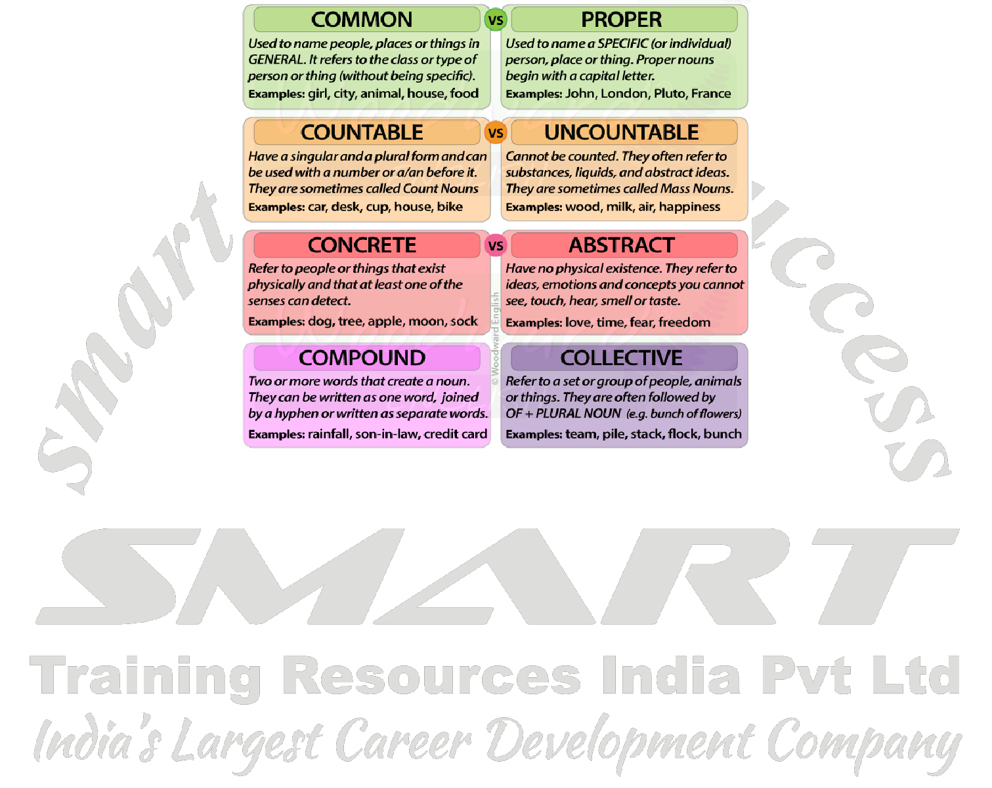

There are many different types of nouns. As you know, you capitalise some nouns, such as "Canada" or "Louise," and do not capitalise others, such as "badger" or "tree" (unless they appear at the beginning of a sentence). In fact, grammarians have developed a whole series of noun types, including the proper noun, the common noun, the concrete noun, the abstract noun, the countable noun (also called the count noun), the non-countable noun (also called the mass noun), and the collective noun. You should note that a noun will belong to more than one type: it will be proper or common, abstract or concrete, *and* countable or non-countable or collective.

If you are interested in the details of these different types, you can read about them in the following sections. ***Proper Nouns***

You always write a **proper noun** with a capital letter, since the noun represents the name of a specific person, place, or thing. The names of days of the week, months, historical documents, institutions, organisations, religions, their holy texts and their adherents are proper nouns. A proper noun is the opposite of a common noun

In each of the following sentences, the proper nouns are **highlighted**:

The **Marroons** were transported from **Jamaica** and forced to build the fortifications in **Halifax**.

Many people dread **Monday** mornings.

**Beltane** is celebrated on the first of **May**.

**Abraham** appears in the **Talmud** and in the **Koran**.

Last year, I had a **Baptist**, a **Buddhist**, and a **Gardnerian Witch** as roommates.



Page **4** of **75**

**VERBAL ABILITY**



**HSEM2BTECHSTANDARDVA1119**

***Common Nouns***

A **common noun** is a noun referring to a person, place, or thing in a general sense -- usually, you should write it with a capital letter only when it begins a sentence. A common noun is the opposite of a proper noun.

In each of the following sentences, the common nouns are **highlighted**:

According to the **sign**, the nearest **town** is 60 **miles** away.

All the **gardens** in the **neighbourhood** were invaded by **beetles** this **summer**.

I don't understand why some **people** insist on having six different **kinds** of **mustard** in their **cupboards**.

The road **crew** was startled by the **sight** of three large **moose** crossing the **road**.



Many child-care **workers** are underpaid.

Sometimes you will make proper nouns out of common nouns, as in the following examples:

The tenants in the **Garnet Apartments** are appealing the large and sudden increase in their rent.

The meals in the Bouncing **Bean Restaurant** are less expensive than meals in ordinary restaurants.

Many witches refer to the Renaissance as the Burning **Times**.

The **Diary of Anne Frank** is often a child's first introduction to the history of the **Holocaust**.

***Concrete Nouns***

A **concrete noun** is a noun which names anything (or anyone) that you can perceive through your physical senses:

touch, sight, taste, hearing, or smell. A concrete noun is the opposite of a abstract noun.

The **highlighted** words in the following sentences are all concrete nouns:

The **judge** handed the **files** to the **clerk**.

Whenever they take the **dog** to the **beach**, it spends hours chasing **waves**.

The real estate **agent** urged the **couple** to buy the second **house** because it had new **shingles**.

As the **car** drove past the **park**, the **thump** of a disco **tune** overwhelmed the string **quartet's rendition** of a **minuet**.

The **book binder** replaced the flimsy paper **cover** with a sturdy, cloth-covered **board**.

***Abstract Nouns***

An **abstract noun** is a noun which names anything which you can *not* perceive through your five physical senses, and is the opposite of a concrete noun. The **highlighted** words in the following sentences are all abstract nouns:

Buying the fire extinguisher was an **afterthought**.

Tillie is amused by people who are nostalgic about **childhood**.

**Justice** often seems to slip out of our grasp.

Some scientists believe that **schizophrenia** is transmitted genetically.

***Countable Nouns***

A **countable noun** (or **count noun**) is a noun with both a singular and a plural form, and it names anything (or anyone) that you can *count*. You can make a countable noun plural and attach it to a plural verb in a sentence. Countable nouns are the opposite of non-countable nouns and collective nouns.



Page **5** of **75**

**VERBAL ABILITY**



**HSEM2BTECHSTANDARDVA1119**

In each of the following sentences, the **highlighted** words are countable nouns:

We painted the **table** red and the **chairs** blue.

Since he inherited his **aunt's library**, Jerome spends every **weekend** indexing his **books**.

Miriam found six silver **dollars** in the **toe** of a **sock**.

The oak **tree** lost three **branches** in the **hurricane**.

Over the **course** of twenty-seven **years**, Martha Ballad delivered just over eight hundred **babies**.

***Non-Countable Nouns***

A **non-countable noun** (or **mass noun**) is a noun which does not have a plural form, and which refers to something that you could (or would) not usually count. A non-countable noun always takes a singular verb in a sentence. Non-countable nouns are similar to collective nouns, and are the opposite of countable nouns.



The **highlighted** words in the following sentences are non-countable nouns:

Joseph Priestly discovered **oxygen**.

The word "oxygen" cannot normally be made plural.

**Oxygen** is essential to human life.

Since "oxygen" is a non-countable noun, it takes the singular verb "is" rather than the plural verb "are."

We decided to sell the **furniture** rather than take it with us when we moved.

You cannot make the noun "furniture" plural.

The **furniture** is heaped in the middle of the room.

Since "furniture" is a non-countable noun, it takes a singular verb, "is heaped."

The crew spread the **gravel** over the roadbed.

You cannot make the non-countable noun "gravel" plural.

**Gravel** is more expensive than I thought.

Since "gravel" is a non-countable noun, it takes the singular verb form "is."

***Collective Nouns***

A **collective noun** is a noun naming a group of things, animals, or persons. You could count the individual members of the group, but you usually think of the group as a whole is generally as one unit. You need to be able to recognise collective nouns in order to maintain subject-verb agreement. A collective noun is similar to a non-countable noun, and is roughly the opposite of a countable noun.

In each of the following sentences, the **highlighted** word is a collective noun:

The **flock** of geese spends most of its time in the pasture.

The collective noun "flock" takes the singular verb "spends."

The **jury** is dining on take-out chicken tonight.

In this example the collective noun "jury" is the subject of the singular compound verb "is dining."



Page **6** of **75**

**VERBAL ABILITY**



**HSEM2BTECHSTANDARDVA1119**

The steering **committee** meets every Wednesday afternoon.

Here the collective noun "committee" takes a singular verb, "meets."

The **class** was startled by the bursting light bulb.

In this sentence the word "class" is a collective noun and takes the singular compound verb "was startled."

1. **PRONOUN**

* **A pronoun is a word used in place of a noun.**

*She... we... they... it*



A pronoun is usually substituted for a specific noun, which is called its antecedent. In the sentence above, the antecedent for the pronoun she is the girl. Pronouns are further defined by type: personal pronouns refer to specific persons or things; possessive pronouns indicate ownership; reflexive pronouns are used to emphasize another noun or pronoun; relative pronouns introduce a subordinate clause; and demonstrative pronouns identify, point to, or refer to nouns.

*The young girl brought* ***me*** *a very long letter from the teacher, and then* ***she*** *quickly disappeared.*

**Personal Pronouns**

A **personal pronoun** refers to a specific person or thing and changes its form to indicate person, number, gender, and case.

***Subjective Personal Pronouns***

A **subjective personal pronoun** indicates that the pronoun is acting as the subject of the sentence. The subjective personal pronouns are "I," "you," "she," "he," "it," "we," "you," "they."

In the following sentences, each of the **highlighted** words is a subjective personal pronoun and acts as the subject of the sentence:

**I** was glad to find the bus pass in the bottom of the green knapsack.

**You** are surely the strangest child **I** have ever met.

**He** stole the selkie's skin and forced her to live with him.

When **she** was a young woman, **she** earned her living as a coal miner.

After many years, **they** returned to their homeland.

**We** will meet at the library at 3:30 p.m.

**It** is on the counter.

Are **you** the delegates from Malagawatch?

***Objective Personal Pronouns***

An **objective personal pronoun** indicates that the pronoun is acting as an object of a verb, compound verb, preposition, or infinitive phrase. The objective personal pronouns are: "me," "you," "her," "him," "it," "us," "you," and "them."

In the following sentences, each of the **highlighted** words is an objective personal pronoun:

Seamus stole the selkie's skin and forced **her** to live with **him**.

The objective personal pronoun "her" is the direct object of the verb "forced" and the objective personal pronoun "him" is the object of the preposition "with."



Page **7** of **75**

**VERBAL ABILITY**



**HSEM2BTECHSTANDARDVA1119**

After reading the pamphlet, Judy threw **it** into the garbage can.

The pronoun "it" is the direct object of the verb "threw."

The agitated assistant stood up and faced the angry delegates and said, "Our leader will address **you** in five minutes."

In this sentence, the pronoun "you" is the direct object of the verb "address."

Deborah and Roberta will meet **us** at the newest café in the market.

Here the objective personal pronoun "us" is the direct object of the compound verb "will meet."

Give the list to **me**.

Here the objective personal pronoun "me" is the object of the preposition "to."



I'm not sure that my contact will talk to **you**.

Similarly in this example, the objective personal pronoun "you" is the object of the preposition "to."

Christopher was surprised to see **her** at the drag races.

Here the objective personal pronoun "her" is the object of the infinitive phrase "to see."

***Possessive Personal Pronouns***

A **possessive pronoun** indicates that the pronoun is acting as a marker of possession and defines who owns a particular object or person. The **possessive personal pronouns** are "mine," "yours," "hers," "his," "its," "ours," and "theirs." Note that possessive personal pronouns are very similar to possessive adjectives like "my," "her," and "their."

In each of the following sentences, the **highlighted** word is a possessive personal pronoun:

The smallest gift is **mine**.

Here the possessive pronoun "mine" functions as a subject complement.

This is yours.

Here too the possessive pronoun "yours" functions as a subject complement.

His is on the kitchen counter.

In this example, the possessive pronoun "his" acts as the subject of the sentence.

Theirs will be delivered tomorrow.

In this sentence, the possessive pronoun "theirs" is the subject of the sentence.

Ours is the green one on the corner.

Here too the possessive pronoun "ours" function as the subject of the sentence.

***Demonstrative Pronouns***

A **demonstrative pronoun** points to and identifies a noun or a pronoun. "This" and "these" refer to things that are nearby either in space or in time, while "that" and "those" refer to things that are farther away in space or time.

The demonstrative pronouns are "this," "that," "these," and "those." "This" and "that" are used to refer to singular nouns or noun phrases and "these" and "those" are used to refer to plural nouns and noun phrases. Note that the demonstrative pronouns are identical to demonstrative adjectives, though, obviously, you use them differently. It is also important to note that "that" can also be used as a relative pronoun.



Page **8** of **75**

**VERBAL ABILITY**



**HSEM2BTECHSTANDARDVA1119**

In the following sentences, each of the **highlighted** words is a demonstrative pronoun:

**This** must not continue.

Here "this" is used as the subject of the compound verb "must not continue."

**This** is puny; **that** is the tree I want.

In this example "this" is used as subject and refers to something close to the speaker. The demonstrative pronoun "that" is also a subject but refers to something farther away from the speaker.

Three customers wanted **these**.

Here "these" is the direct object of the verb "wanted."



***Interrogative Pronouns***

An **interrogative pronoun** is used to ask questions. The interrogative pronouns are "who," "whom," "which," "what" and the compounds formed with the suffix "ever" ("whoever," "whomever," "whichever," and "whatever"). Note that either "which" or "what" can also be used as an interrogative adjective, and that "who," "whom," or "which" can also be used as a relative pronoun.

You will find "who," "whom," and occasionally "which" used to refer to people, and "which" and "what" used to refer to things and to animals.

"Who" acts as the subject of a verb, while "whom" acts as the object of a verb, preposition, or a verbal.

The **highlighted** word in each of the following sentences is an interrogative pronoun:

**Which** wants to see the dentist first?

"Which" is the subject of the sentence.

**Who** wrote the novel Rockbound?

Similarly "who" is the subject of the sentence.

**Whom** do you think we should invite?

In this sentence, "whom" is the object of the verb "invite."

To **whom** do you wish to speak?

Here the interrogative pronoun "whom" is the object of the preposition "to."

**Who** will meet the delegates at the train station?

In this sentence, the interrogative pronoun "who" is the subject of the compound verb "will meet."

To **whom** did you give the paper?

In this example the interrogative pronoun "whom" is the object of the preposition "to."

**What** did she say?

Here the interrogative pronoun "what" is the direct object of the verb "say."

***Relative Pronouns***

You can use a **relative pronoun** is used to link one phrase or clause to another phrase or clause. The relative pronouns are "who," "whom," "that," and "which." The compounds "whoever," "whomever," and "whichever" are also relative pronouns.



Page **9** of **75**

**VERBAL ABILITY**



**HSEM2BTECHSTANDARDVA1119**

You can use the relative pronouns "who" and "whoever" to refer to the subject of a clause or sentence, and "whom" and "whomever" to refer to the objects of a verb, a verbal or a preposition.

In each of the following sentences, the **highlighted** word is a relative pronoun.

You may invite **whomever** you like to the party.

The relative pronoun "whomever" is the direct object of the compound verb "may invite."

The candidate **who** wins the greatest popular vote is not always elected.

In this sentence, the relative pronoun is the subject of the verb "wins" and introduces the subordinate clause "who wins the greatest popular vote." This subordinate clause acts as an adjective modifying "candidate."

In a time of crisis, the manager asks the workers **whom** she believes to be the most efficient to arrive an hour earlier than usual.



In this sentence "whom" is the direct object of the verb "believes" and introduces the subordinate clause "whom she believes to be the most efficient". This subordinate clause modifies the noun "workers."

**Whoever** broke the window will have to replace it.

Here "whoever" functions as the subject of the verb "broke."

The crate **which** was left in the corridor has now been moved into the storage closet.

In this example "which" acts as the subject of the compound verb "was left" and introduces the subordinate clause "which was left in the corridor." The subordinate clause acts as an adjective modifying the noun "crate."

I will read **whichever** manuscript arrives first.

Here "whichever" modifies the noun "manuscript" and introduces the subordinate clause "whichever manuscript arrives first." The subordinate clause functions as the direct object of the compound verb "will read."

***Indefinite Pronouns***

An **indefinite pronoun** is a pronoun referring to an identifiable but not specified person or thing. An indefinite pronoun conveys the idea of all, any, none, or some.

The most common indefinite pronouns are "all," "another," "any," "anybody," "anyone," "anything," "each," "everybody," "everyone," "everything," "few," "many," "nobody," "none," "one," "several," "some," "somebody," and "someone." Note that some indefinite pronouns can also be used as indefinite adjectives.

The **highlighted** words in the following sentences are indefinite pronouns:

**Many** were invited to the lunch but only twelve showed up.

Here "many" acts as the subject of the compound verb "were invited."

The office had been searched and **everything** was thrown onto the floor.

In this example, "everything" acts as a subject of the compound verb "was thrown."

We donated **everything** we found in the attic to the woman's shelter garage sale.

In this sentence, "everything" is the direct object of the verb "donated."

Although they looked everywhere for extra copies of the magazine, they found **none**.

Here too the indefinite pronoun functions as a direct object: "none" is the direct object of "found."

Make sure you give **everyone** a copy of the amended bylaws.



Page **10** of **75**

**VERBAL ABILITY**



**HSEM2BTECHSTANDARDVA1119**

In this example, "everyone" is the indirect object of the verb "give" -- the direct object is the noun phrase "a copy of the amended bylaws."

Give a registration package to **each**.

Here "each" is the object of the preposition "to."

***Reflexive Pronouns***

You can use a **reflexive pronoun** to refer back to the subject of the clause or sentence.

The reflexive pronouns are "myself," "yourself," "herself," "himself," "itself," "ourselves," "yourselves," and "themselves." Note each of these can also act as an intensive pronoun.



Each of the **highlighted** words in the following sentences is a reflexive pronoun:

Diabetics give **themselves** insulin shots several times a day.

The Dean often does the photocopying **herself** so that the secretaries can do more important work.

After the party, I asked **myself** why I had faxed invitations to everyone in my office building.

Richard usually remembered to send a copy of his e-mail to **himself**.

Although the landlord promised to paint the apartment, we ended up doing it **ourselves**.

***Intensive Pronouns***

An **intensive pronoun** is a pronoun used to emphasise its antecedent. Intensive pronouns are identical in form to reflexive pronouns.

The **highlighted** words in the following sentences are intensive pronouns:

I **myself** believe that aliens should abduct my sister.

The Prime Minister **himself** said that he would lower taxes.

They **themselves** promised to come to the party even though they had a final exam at the same time.

1. **VERB**

* **A verb expresses action or being.**

*jump... is... write... become*

The verb in a sentence expresses action or being. There is a main verb and sometimes one or more helping verbs. ("*She can sing." Sing* is the main verb; *can* is the modal verb.) A verb must agree with its subject in number (both are singular or both are plural). Verbs also take different forms to express tense.

*The young girl* ***brought*** *me a very long letter from the teacher, and then she quickly* ***disappeared****.*

The verb or compound verb is the critical element of the predicate of a sentence.

In each of the following sentences, the verb or compound verb is **highlighted**:

Dracula **bites** his victims on the neck.

The verb "bites" describes the action Dracula takes.

In early October, Giselle **will plant** twenty tulip bulbs.



Page **11** of **75**

**VERBAL ABILITY**



**HSEM2BTECHSTANDARDVA1119**

Here the compound verb "will plant" describes an action that will take place in the future.

My first teacher **was** Miss Crawford, but I remember the janitor Mr. Weatherbee more vividly.

In this sentence, the verb "was" (the simple past tense tense of "is") identifies a particular person and the verb "remember" describes a mental action.

Karl Creelman bicycled around the world in 1899, but his diaries and his bicycle **were destroyed**.

In this sentence, the compound verb "were destroyed" describes an action which took place in the past.

1. **ADJECTIVE**

* **An adjective modifies or describes a noun or pronoun.**



*pretty... old... blue... smart*

An adjective is a word used to modify or describe a noun or a pronoun. It usually answers the question of which one, what kind, or how many. (Articles [a, an, the] are usually classified as adjectives.)

*The* ***young*** *girl brought me a very* ***long*** *letter from the teacher, and then she quickly disappeared.*

In the following examples, the **highlighted** words are adjectives:

The **truck-shaped** balloon floated over the treetops.

Mrs. Morrison papered her **kitchen** walls with **hideous** wall paper.

The **small** boat foundered on the **wine dark** sea.

The **coal** mines are **dark** and **dank**.

**Many** stores have already begun to play **irritating Christmas** music.

A **battered music** box sat on the **mahogany** sideboard.

The back room was filled with **large**, **yellow** rain boots.

An adjective can be modified by an adverb, or by a phrase or clause functioning as an adverb. In the sentence

My husband knits intricately **patterned** mittens.

For example, the adverb "intricately" modifies the adjective "patterned."

Some nouns, many pronouns, and many participle phrases can also act as adjectives. In the sentence

Eleanor listened to the **muffled** sounds of the radio **hidden** under her pillow.

For example, both **highlighted** adjectives are past participles.

Grammarians also consider **articles** ("the," "a," "an") to be adjectives.

***Possessive Adjectives***

A **possessive adjective** ("my," "your," "his," "her," "its," "our," "their") is similar or identical to a possessive pronoun; however, it is used as an adjective and modifies a noun or a noun phrase, as in the following sentences:

I can't complete **my** assignment because I don't have the textbook.

In this sentence, the possessive adjective "my" modifies "assignment" and the noun phrase "my assignment" functions as an object. Note that the possessive pronoun form "mine" is not used to modify a noun or noun phrase.



Page **12** of **75**

**VERBAL ABILITY**



**HSEM2BTECHSTANDARDVA1119**

What is **your** phone number.

Here the possessive adjective "your" is used to modify the noun phrase "phone number"; the entire noun phrase "your phone number" is a subject complement. Note that the possessive pronoun form "yours" is not used to modify a noun or a noun phrase.

The bakery sold **his** favourite type of bread.

In this example, the possessive adjective "his" modifies the noun phrase "favourite type of bread" and the entire noun phrase "his favourite type of bread" is the direct object of the verb "sold."

After many years, she returned to **her** homeland.

Here the possessive adjective "her" modifies the noun "homeland" and the noun phrase "her homeland" is the object of the preposition "to" Note also that the form "hers" is not used to modify nouns or noun phrases.



We have lost **our** way in this wood.

In this sentence, the possessive adjective "our" modifies "way" and the noun phrase "our way" is the direct object of the compound verb "have lost". Note that the possessive pronoun form "ours" is not used to modify nouns or noun phrases.

In many fairy tales, children are neglected by **their** parents.

Here the possessive adjective "their" modifies "parents" and the noun phrase "their parents" is the object of the preposition "by." Note that the possessive pronoun form "theirs" is not used to modify nouns or noun phrases.

The cat chased **its** ball down the stairs and into the backyard.

In this sentence, the possessive adjective "its" modifies "ball" and the noun phrase "its ball" is the object of the verb "chased." Note that "its" is the possessive adjective and "it's" is a contraction for "it is."

***Demonstrative Adjectives***

The **demonstrative adjectives** "this," "these," "that," "those," and "what" are identical to the demonstrative pronouns, but are used as adjectives to modify nouns or noun phrases, as in the following sentences:

When the librarian tripped over **that** cord, she dropped a pile of books.

In this sentence, the demonstrative adjective "that" modifies the noun "cord" and the noun phrase "that cord" is the object of the preposition "over."

**This** apartment needs to be fumigated.

Here "this" modifies "apartment" and the noun phrase "this apartment" is the subject of the sentence.

Even though my friend preferred **those** plates, I bought these.

In the subordinate clause, "those" modifies "plates" and the noun phrase "those plates" is the object of the verb "preferred." In the independent clause, "these" is the direct object of the verb "bought."

Note that the relationship between a demonstrative adjective and a demonstrative pronoun is similar to the relationship between a possessive adjective and a possessive pronoun, or to that between an interrogative adjective and an interrogative pronoun.

***Interrogative Adjectives***

An **interrogative adjective** ("which" or "what") is like an interrogative pronoun, except that it modifies a noun or noun phrase rather than standing on its own (see also demonstrative adjectives and possessive adjectives):



Page **13** of **75**

**VERBAL ABILITY**



**HSEM2BTECHSTANDARDVA1119**

**Which** plants should be watered twice a week?

Like other adjectives, "which" can be used to modify a noun or a noun phrase. In this example, "which" modifies "plants" and the noun phrase "which plants" is the subject of the compound verb "should be watered":

**What** book are you reading?

In this sentence, "what" modifies "book" and the noun phrase "what book" is the direct object of the compound verb "are reading."

***Indefinite Adjectives***

An **indefinite adjective** is similar to an indefinite pronoun, except that it modifies a noun, pronoun, or noun phrase, as in the following sentences:



Many people believe that corporations are under-taxed.

The indefinite adjective "many" modifies the noun "people" and the noun phrase "many people" is the subject of the sentence.

I will send you any mail that arrives after you have moved to Sudbury.

The indefinite adjective "any" modifies the noun "mail" and the noun phrase "any mail" is the direct object of the compound verb "will send."

They found a few goldfish floating belly up in the swan pound.

In this example the indefinite adjective modifies the noun "goldfish" and the noun phrase is the direct object of the verb "found":

The title of Kelly's favourite game is "All dogs go to heaven."

Here the indefinite pronoun "all" modifies "dogs" and the full title is a subject complement.

1. **ADVERB**

* **An adverb modifies or describes a verb, an adjective, or another adverb.**

*gently... extremely... carefully... well*

An adverb describes or modifies a verb, an adjective, or another adverb, but never a noun. It usually answers the questions of when, where, how, why, under what conditions, or to what degree. Adverbs often end in -ly.

*The young girl brought me a* ***very*** *long letter from the teacher, and she* ***quickly*** *disappeared.*

In the following examples, each of the **highlighted** words is an adverb:

The seamstress **quickly** made the mourning clothes.

In this sentence, the adverb "quickly" modifies the verb "made" and indicates in what manner (or how fast) the clothing was constructed.

The midwives waited **patiently** through a long labour.

Similarly in this sentence, the adverb "patiently" modifies the verb "waited" and describes the manner in which the midwives waited.

The **boldly** spoken words would return to haunt the rebel.



Page **14** of **75**

**VERBAL ABILITY**



**HSEM2BTECHSTANDARDVA1119**

In this sentence the adverb "boldly" modifies the adjective "spoken."

We urged him to dial the number more **expeditiously**.

Here the adverb "more" modifies the adverb "expeditiously."

**Unfortunately**, the bank closed at three **today**.

In this example, the adverb "unfortunately" modifies the entire sentence.

***Conjunctive Adverbs***

You can use a **conjunctive adverb** to join two clauses together. Some of the most common conjunctive adverbs are "also," "consequently," "finally," "furthermore," "hence," "however," "incidentally," "indeed," "instead," "likewise," "meanwhile," "nevertheless," "next," "nonetheless," "otherwise," "still," "then," "therefore," and "thus." A conjunctive adverb is *not* strong enough to join two independent clauses without the aid of a semicolon.



The **highlighted** words in the following sentences are conjunctive adverbs:

The government has cut university budgets; **consequently**, class sizes have been increased.

He did not have all the ingredients the recipe called for; **therefore**, he decided to make something else.

The report recommended several changes to the ways the corporation accounted for donations; **furthermore**, it suggested that a new auditor be appointed immediately.

The crowd waited patiently for three hours; **finally**, the doors to the stadium were opened.

Batman and Robin fruitlessly searched the building; **indeed**, the Joker had escaped through a secret door in the basement.

1. **PREPOSITION**

* **A preposition is a word placed before a noun or pronoun to form a phrase modifying another word in the sentence.**

*by... with.... about... until*

(by the tree, with our friends, about the book, until tomorrow)

A preposition is a word placed before a noun or pronoun to form a phrase modifying another word in the sentence. Therefore a preposition is always part of a prepositional phrase. The prepositional phrase almost always functions as an adjective or as an adverb. The following list includes the most common prepositions:

*The young girl brought me a very long letter* ***from******the teacher****, and then she quickly disappeared.*

A preposition usually indicates the temporal, spatial or logical relationship of its object to the rest of the sentence as in the following examples:

The book is **on** the table.

The book is **beneath** the table.

The book is leaning **against** the table.

The book is **beside** the table.

She held the book **over** the table.

She read the book **during** class.



Page **15** of **75**

**VERBAL ABILITY**



**HSEM2BTECHSTANDARDVA1119**

In each of the preceding sentences, a preposition locates the noun "book" in space or in time.

A prepositional phrase is made up of the preposition, its object and any associated adjectives or adverbs. A prepositional phrase can function as a noun, an adjective, or an adverb. The most common prepositions are "about," "above," "across," "after," "against," "along," "among," "around," "at," "before," "behind," "below," "beneath," "beside," "between," "beyond," "but," "by," "despite," "down," "during," "except," "for," "from," "in," "inside," "into," "like," "near," "of," "off," "on," "onto," "out," "outside," "over," "past," "since," "through," "throughout," "till," "to," "toward," "under," "underneath," "until," "up," "upon," "with," "within," and "without."

Each of the **highlighted** words in the following sentences is a preposition:

The children climbed the mountain **without** fear.

In this sentence, the preposition "without" introduces the noun "fear." The prepositional phrase "without fear" functions as an adverb describing how the children climbed.



There was rejoicing **throughout** the land when the government was defeated.

Here, the preposition "throughout" introduces the noun phrase "the land." The prepositional phrase acts as an adverb describing the location of the rejoicing.

The spider crawled slowly **along** the banister.

The preposition "along" introduces the noun phrase "the banister" and the prepositional phrase "along the banister" acts as an adverb, describing where the spider crawled.

The dog is hiding **under** the porch because it knows it will be punished **for** chewing up a new pair **of** shoes.

Here the preposition "under" introduces the prepositional phrase "under the porch," which acts as an adverb modifying the compound verb "is hiding."

The screenwriter searched **for** the manuscript he was certain was somewhere **in** his office.

Similarly in this sentence, the preposition "in" introduces a prepositional phrase "in his office," which acts as an adverb describing the location of the missing papers.

1. **CONJUNCTION**

* **A conjunction joins words, phrases, or clauses.**

*and... but... or... while... because*

A conjunction joins words, phrases, or clauses, and indicates the relationship between the elements joined. Coordinating conjunctions connect grammatically equal elements: and, but, or, nor, for, so, yet. Subordinating conjunctions connect clauses that are not equal: because, although, while, since, etc. There are other types of conjunctions as well.

*The young girl brought me a very long letter from the teacher,* ***and*** *then she quickly disappeared.*

***E***xample:

I ate the pizza **and** the pasta.

Call the movers **when** you are ready.

**Co-ordinating Conjunctions**

You use a **co-ordinating conjunction** ("and," "but," "or," "nor," "for," "so," or "yet") to join individual words, phrases, and independent clauses. Note that you can also use the conjunctions "but" and "for" as prepositions.



Page **16** of **75**

**VERBAL ABILITY**



**HSEM2BTECHSTANDARDVA1119**

In the following sentences, each of the **highlighted** words is a co-ordinating conjunction:

Lilacs **and** violets are usually purple.

In this example, the co-ordinating conjunction "and" links two nouns.

This movie is particularly interesting to feminist film theorists, **for** the screenplay was written by Mae West.

In this example, the co-ordinating conjunction "for" is used to link two independent clauses.

Daniel's uncle claimed that he spent most of his youth dancing on rooftops **and** swallowing goldfish.

Here the co-ordinating conjunction "and" links two participle phrases ("dancing on rooftops" and "swallowing goldfish") which act as adverbs describing the verb "spends."



***Subordinating Conjunctions***

A **subordinating conjunction** introduces a dependent clause and indicates the nature of the relationship among the independent clause(s) and the dependent clause(s).

The most common subordinating conjunctions are "after," "although," "as," "because," "before," "how," "if," "once,"

"since," "than," "that," "though," "till," "until," "when," "where," "whether," and "while."

Each of the **highlighted** words in the following sentences is a subordinating conjunction:

**After** she had learned to drive, Alice felt more independent.

The subordinating conjunction "after" introduces the dependent clause "After she had learned to drive." **If** the paperwork arrives on time, your cheque will be mailed on Tuesday.

Similarly, the subordinating conjunction "if" introduces the dependent clause "If the paperwork arrives on time." Gerald had to begin his thesis over again **when** his computer crashed.

The subordinating conjunction "when" introduces the dependent clause "when his computer crashed."

Midwifery advocates argue that home births are safer **because** the mother and baby are exposed to fewer people and fewer germs.

In this sentence, the dependent clause "because the mother and baby are exposed to fewer people and fewer germs" is introduced by the subordinating conjunction "because."

***Correlative Conjunctions***

**Correlative conjunctions** always appear in pairs -- you use them to link equivalent sentence elements. The mostcommon correlative conjunctions are "both...and," "either...or," "neither...nor,", "not only...but also," "so...as," and "whether...or." (Technically correlative conjunctions consist simply of a co-ordinating conjunction linked to an adjective or adverb.)

The **highlighted** words in the following sentences are correlative conjunctions:

**Both** my grandfather **and** my father worked in the steel plant.

In this sentence, the correlative conjunction "both...and" is used to link the two noun phrases that act as the compound subject of the sentence: "my grandfather" and "my father".

Bring **either** a Jello salad **or** a potato scallop.

Here the correlative conjunction "either...or" links two noun phrases: "a Jello salad" and "a potato scallop." Corinne is trying to decide **whether** to go to medical school **or**to go to law school.

Similarly, the correlative conjunction "whether ... or" links the two infinitive phrases "to go to medical school" and "to go to law school."



Page **17** of **75**

**VERBAL ABILITY**



**HSEM2BTECHSTANDARDVA1119**

The explosion destroyed **not only** the school **but also** the neighbouring pub.

In this example the correlative conjunction "not only ... but also" links the two noun phrases ("the school" and "neighbouring pub") which act as direct objects.

Note: some words which appear as conjunctions can also appear as prepositions or as adverbs.

1. **INTERJECTION**

* **An interjection is a word used to express emotion.**

*Oh!... Wow!... Oops!*

An interjection is a word used to express emotion. It is often followed by an exclamation point.

*The young girl brought me a very long letter from the teacher, and then she quickly disappeared.* ***Oh my****!*



An **interjection** is a word added to a sentence to convey emotion. It is not grammatically related to any other part of the sentence.

You usually follow an interjection with an exclamation mark. Interjections are uncommon in formal academic prose, except in direct quotations.

The **highlighted** words in the following sentences are interjections:

**Ouch**, that hurt!

**Oh no**, I forgot that the exam was today.

**Hey**! Put that down!

I heard one guy say to another guy, "He has a new car, **eh**?"

I don't know about you but, **good lord**, I think taxes are too high!

 **ARTICLES**

There are two kinds of article: definite and indefinite.

The definite article is 'the'. It is used to identify a specific thing.

The indefinite article is 'a' and 'an'. It is used to refer to something in general.

For example:

* **The** cat sat on **the** mat. (We know which cat and which mat.)
* I need **a** ruler. (We do not need a specific ruler, any will do.)
* **The** car would struggle to get up **a** hill. (We can identify which car, but are referring to any hill.)



Page **18** of **75**

**VERBAL ABILITY**



**HSEM2BTECHSTANDARDVA1119**

 **PUNCTUATION**

To fully understand basic grammar rules, you also need to look at punctuation rules.

* **Capitalization** is important. All sentences must start with a capital, or upper-case, letter. Titles of people,books, magazines, movies, specific places, etc. are capitalized. Organizations and compass points are capitalized.
* Every sentence needs a **punctuation mark** at the end of it. These include a period, exclamation mark, or question mark.
* **Colons** are used to separate a sentence from a list of items, to introduce a long, direct quote, or between twosentences (or clauses) when the second one explains the first.
* **Semicolons** can take the place of a conjunction and are placed before introductory words like "therefore" or"however." They are also used to separate a list of things if there are commas within each unit.
* There are a lot of rules for **commas**. The basic ones are that commas separate things in a series and go wherever there is a pause in the sentence. They surround the name of a person being addressed, separate the day of the month from the year in a date, and separate a town from the state.
* **Parentheses** enclose things that clarify or numbers and letters that are part of a list.
* **Apostrophes** are used in contractions to take the place of one or more letters and also to show possession. Anapostrophe and "s" is added if the noun is singular and an apostrophe alone is added if the noun is plural.



 **PHRASAL VERBS AND COLLOCATION**

In English, a phrasal verb is a phrase such as turn down or ran into which combines two or three words from different grammatical categories: a verb and a particle and/or a preposition together form a single semantic unit.

A phrasal verb is a combination of words (a verb + a preposition or verb +adverb) that when used together, usually take on a different meaning to that of the original verb.

When we use phrasal verbs, we use them like normal verbs in a sentence, regardless if it’s a regular or **irregular verb**.

1. Ella **tore up** the letter after she read it.
2. Their car **broke down** two miles out of town.
3. Did the manager **deal with** that customer’s complaint.

Phrasal verbs consist of a verb and a preposition or an adverb:

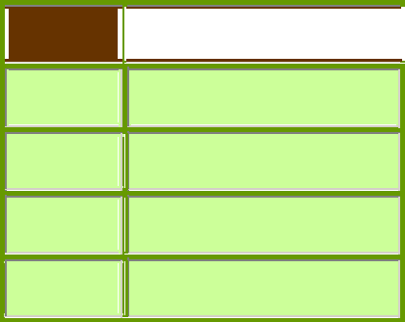

**Verb** **Preposition/adverb**

Get up

Go through

write down

take after



Page **19** of **75**

**VERBAL ABILITY**



**HSEM2BTECHSTANDARDVA1119**

Sometimes phrasal verbs consist of three elements:

|  |  |  |  |
| --- | --- | --- | --- |
| **Verb** | **Preposition / adverb 1** | **Preposition / adverb 2** |  |
|  |
|  |  |  |  |
| look | forward | to |  |
|  |  |  |  |
| Put | up | with |  |
|  |
|  |  |  |  |
| Sit | in | for |  |
|  |
|  |  |  |  |
|  |  |  |  |

When added to the verb the preposition or adverb may change completely the meaning of the verb. Here are some examples:

|  |  |  |  |  |  |
| --- | --- | --- | --- | --- | --- |
| **Phrasal verb** | **Meaning** |  | **Example** |  |  |
|  |  |  |
|  |  |  |  |  |  |
| look for | search/seek |  | He is looking for his keys |  |  |
|  |  |  |  |  |  |
| look up to | have a great deal of respect for a person |  | His father is his model. He is the person he looks up |  |  |
|  |  |  | to. |  |  |
|  |  |  |  |  |  |
| look forward to | await eagerly/anticipate with pleasure |  | She is looking forward to visiting Paris. |  |  |
|  |  |  |  |  |  |
| look up | to try to find a piece of information | by | She didn't understand the word. So she looked it up |  |  |
|  | looking in a book or on a computer: |  | in her dictionary |  |  |
|  |  |  |  |  |  |



**The meaning of phrasal verbs**

Sometimes, it is difficult to understand the meaning of phrasal verbs. Before looking them up in a dictionary, it would be helpful to use the context to understand them.

***Literal meaning***

Some phrasal verbs have a literal meaning. They can be easily understood.

* She opened the door and *looked outside*.
* She was *walking across* the street when she heard the sound of an explosion.

***Idiomatic meaning***

Phrasal verbs can also have a figurative or idiomatic meaning which makes them difficult to understand.

* Can you *put* me *up* for tonight?
* The phrasal verb *'put up*' here does not mean to build (as in *putting a fence up*). It has, however, an idiomatic/figurative meaning. It means to let someone stay in your house.

**Separable or inseparable?**

1. Sometimes, the preposition/adverb is placed either after the verb or after the object.

**Examples:**

* + Mary ***made up*** a really entertaining story.
  + Mary ***made*** the story ***up***.

1. If the object is a pronoun, however, the preposition/adverb has to be placed after the pronoun (object).



Page **20** of **75**

**VERBAL ABILITY**

**Examples:**

* + She ***made*** it ***up***.
  + ***Put*** it ***down.***
  + ***Take*** it ***off.***

1. Some phrasal verbs are always inseparable.

**Example:**

* I ***came across*** some old photos in a drawer.

NOT

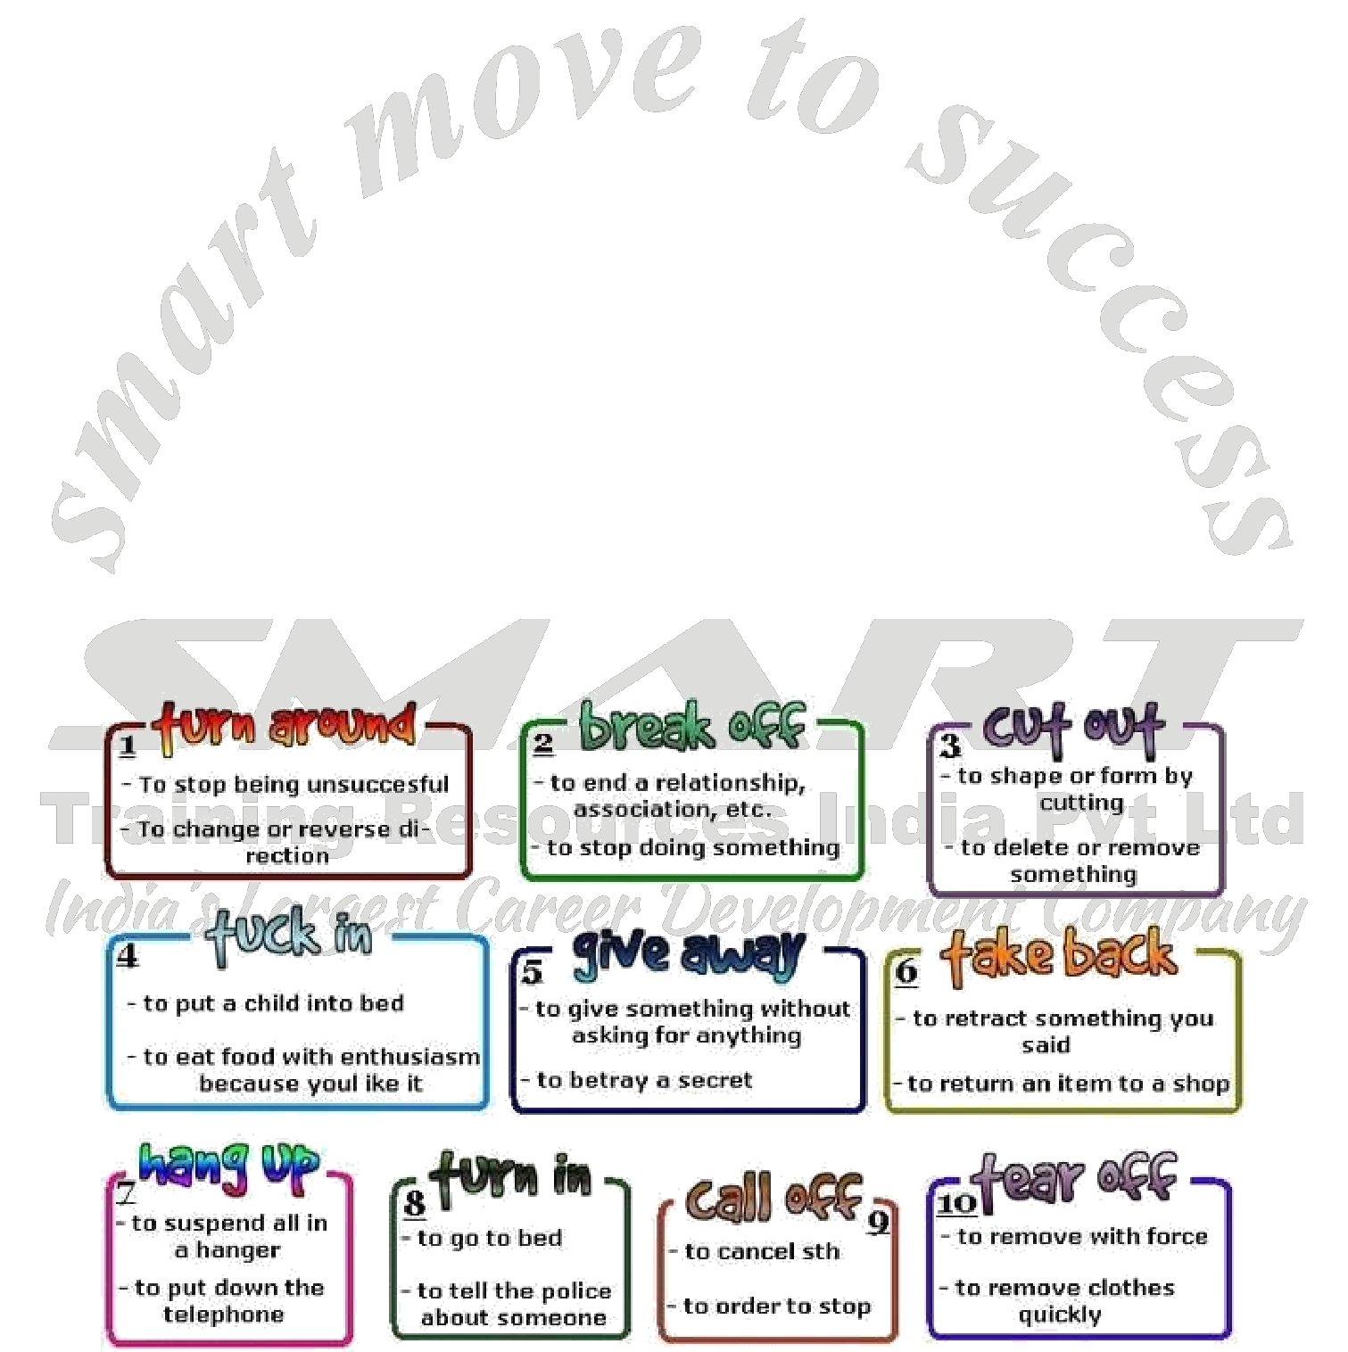

* ~~I~~ ***~~came~~*** ~~some old photos~~ ***~~across~~*** ~~in a drawer.~~

**More phrasal verb examples:**

1. Be sure to **put on** a life jacket before getting into the boat.
2. We **left out** the trash for pickup.
3. It’s time to **get on** the plane.
4. What will she **think up** next?
5. I’m having some trouble **working out** the solution to this equation.
6. We’re going to have to **put off** our vacation until next year.
7. **Stand up** when speaking in class, please.
8. We’ll have to **wake up** early if we want breakfast.
9. **Take off** your shoes before you walk on the carpet.
10. My dog likes to **break out** of his kennel to chase squirrels.



**HSEM2BTECHSTANDARDVA1119**



Page **21** of **75**

**VERBAL ABILITY**



**HSEM2BTECHSTANDARDVA1119**

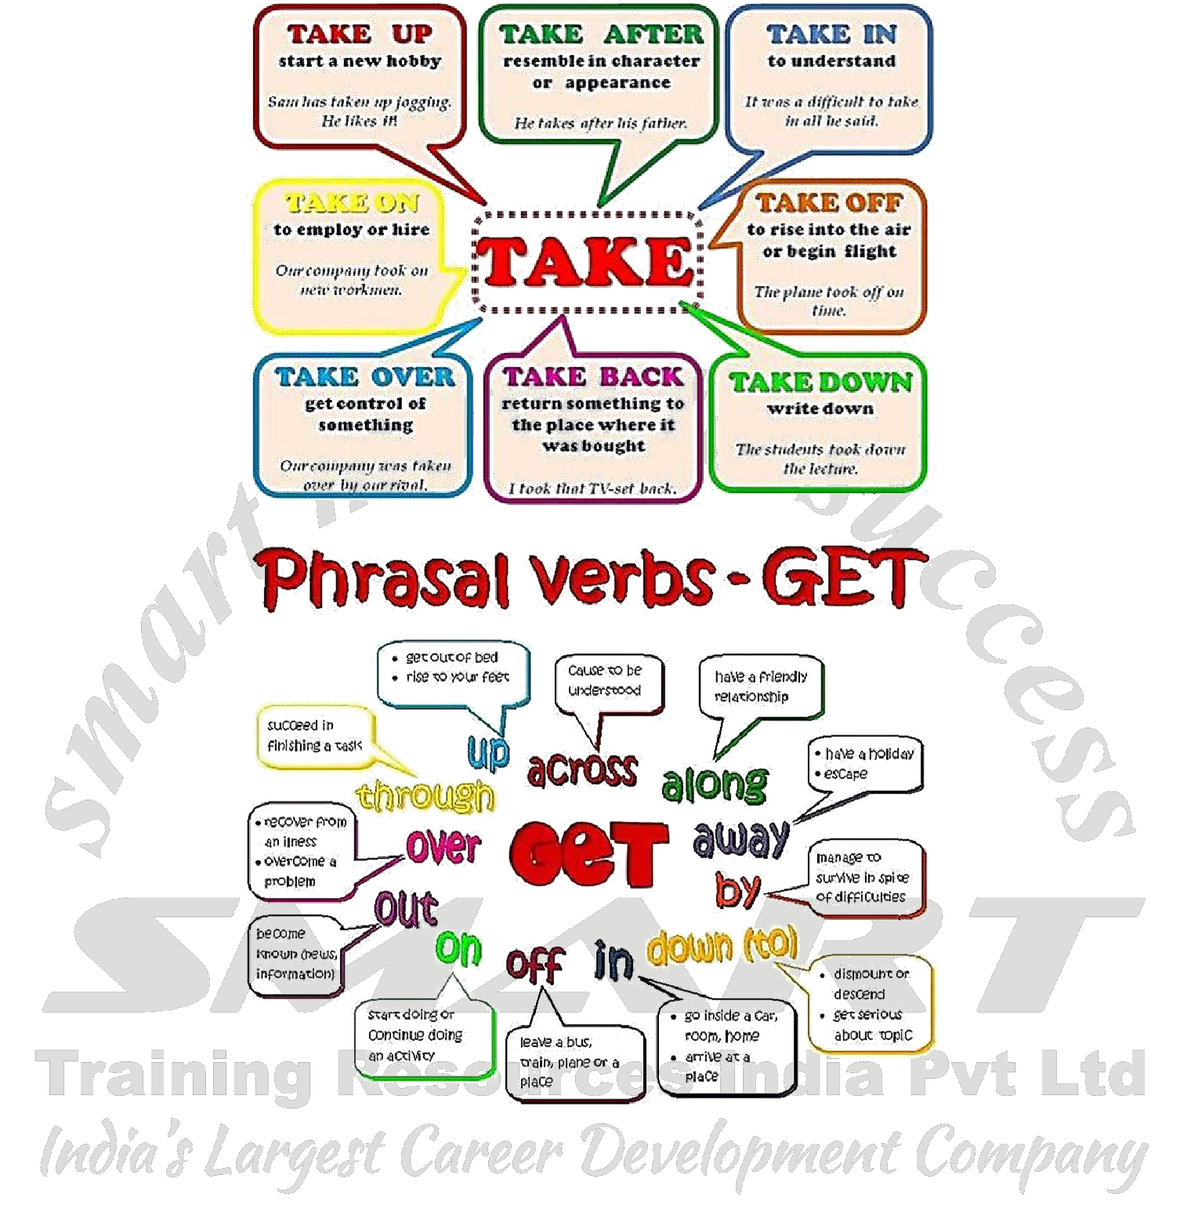

**PHRASAL VERB**

**Exercise 1**

Choose the correct phrasal verb from the parenthesis at the end of the sentence.

1. Someone broke into my car last night and stole the stereo. (broke down/broke into)
2. Will you be able to get by this month with the little you have?(get off / get by)
3. His father always taught him not to ___________ those people with less. (look up to / look down on)
4. Stop complaining and ___________ your work! (get on with / get over)
5. The boss wants you to ___________ your figures for this month to him. (hand out / hand in)
6. We’re going to have to ___________ our trip to Spain until September. (put up/ put off)



Page **22** of **75**

**VERBAL ABILITY**



**HSEM2BTECHSTANDARDVA1119**

1. I ___________ Amir today at the supermarket. It was great to see him. (ran out of / ran into)
2. I’m so tired of Sophie ___________ her engagement ring all the time. (showing off, showing up)
3. The police would not ___________ to the kidnapper’s demands. (give up/ give in)
4. I thought I would ___________ for a cup of coffee. Is that okay? (drop off/ drop in)
5. Have you ever ___________ such an unusual piece of art? (come forward/come across)
6. It’s important to ___________ on time. (show up / show off)
7. ___________ your feet when walking; you don’t want to trip! (uplift / lift up)
8. The tree was ___________ by the wind. (blown up / blown over)
9. He ___________ his hat to show me his new haircut. (took off / took up)
10. I just can’t seem to ___________ this book. (get off / get into )



 **COLLOCATION**

A **collocation** is made up of two or more words that are commonly used together in **English**. Think of **collocations** as words that usually go together. There are different kinds of **collocations** in **English**. Strong **collocations** are word pairings that are expected to come together.

In the English language, collocation refers to a natural combination of words that are closely affiliated with each other. Some examples are "pay attention", "fast food", "make an effort"

Collocation refers to how words go together or form fixed relationships.

|  |  |
| --- | --- |
| typical collocations | incorrect/untypical collocations |
| ***heavy*** *rain* | ~~thick rain~~ |
| ***high*** *temperature* | ~~tall temperature~~ |
| ***scenic*** *view* | ~~scenic picture~~ |
| ***have*** *an experience* | ~~do/make an experience~~ |

*She has* ***blonde*** *hair.*

Not: ~~She has beige hair~~.

*She was* ***discharged*** *from hospital.*

Not: ~~She was released from hospital~~.

Collocations may be strong or weak. Strong collocations are where the link between the two words is quite fixed and restricted. Weak collocations are where a word can collocate with many other words.

**Compare**

**strong**

*make*

*express +* ***a wish***

*fulfil*

**weak**

*apartment, beach, car, camera, chance*,

***big*** *+ disappointment, fight, gun, lamp, moon, news*,*ocean, pain, pity, price, queue, table, umbrella*, *upset, wait, window*

Very few words can collocate with the noun *wish*. This makes *wish a* strong collocator.

*big* can collocate with hundreds of words, therefore it’sa weak collocator.



Page **23** of **75**

**VERBAL ABILITY**



**HSEM2BTECHSTANDARDVA1119**

Strong collocations

***whisk an egg***

***curly hair***

***winding road***

***blissfully ignorant***

Weak collocations

1. *big/enormous/large + house/lorry/cup*
2. *fast/shiny/expensive + car/motorbike/aeroplane*
3. *very/really/extremely + interesting/hot/generous*
4. *brown/straight/long + fence/hair/line*

Becoming aware of collocations is part of vocabulary learning.



**Collocation Examples**

Here are a number of common collocations in English:

|  |  |
| --- | --- |
| to make the bed | *I need to make the bed every day.* |
|  |  |
| to do homework | *My son does his homework after dinner.* |
|  |  |
| to take a risk | *Some people don't take enough risks in life.* |
|  |  |
| to give someone advice | *The teacher gave us some advice on taking tests.* |
|  |  |

**Verb Collocations**

Some of the most common collocations involve verb + noun collocations used in everyday situations. Here are some examples of the types of verb collocations you will need to learn as you continue learning English.:

|  |  |
| --- | --- |
| to feel free | *Please feel free to take a seat and enjoy the show.* |
|  |  |
| to come prepared | *Make sure to come prepared for the test tomorrow.* |
|  |  |
| to save time | *You'll save time if you turn off your smart phone and concentrate on the lesson.* |
|  |  |
| to find a replacement | *We need to find a replacement for Jim as soon as possible.* |
|  |  |
| to make progress | *We're making progress on the project at work.* |
|  |  |
| to do the washing up | *I'll do the washing up and you can put Johnny to bed.* |
|  |  |

**Business Collocations**

Collocations are often used in business and work settings. There are a number of forms including adjectives, nouns and other verbs that combine with keywords to form business expressions.

Here are some business collocations.

These collocations are used for specific situations in business.

|  |  |  |
| --- | --- | --- |
| to open an account | *Would you like to open an account at our bank?* |  |
|  |  |  |
| to forgive a debt | *Do you think the bank would forgive a debt?* |  |
|  |  |  |
| to land a deal | *We landed a deal worth $3 million.* |  |
|  |  |  |
| to key in a PIN | *Just key in your PIN at the ATM and you can make a deposit.* |  |
|  |  |  |
| to deposit a check | *I'd like to deposit this check for $100.* |  |
|  |  |  |
| hard-earned money | *Once you get a job, you'll know what hard-earned money really is.* |  |
|  |  |  |
| to close a deal | *I closed a deal on a new account last week.* |  |
|  |  |  |
| to write up a contract | *Let's write up your contract.* |  |
|  |  |  |
| counterfeit money | *Be on the lookout for counterfeit money in circulation.* |  |
|  |  |  |
|  | Page **24** of **75** | |



**VERBAL ABILITY**



**HSEM2BTECHSTANDARDVA1119**

**Common Expressions**

Collocations are often used as short expressions to describe how someone feels about a situation. In this case, collocations can be used in the adjective form, or also as emphatic expressions using an intensifier and a verb. Here are a few examples using some common collocations:

|  |  |
| --- | --- |
| positively encourage someone to do something | *We'd like to positively encourage you to buy this stock.* |
|  |  |
| deeply regret the loss of someone / something | *I deeply regret the loss of your loved one.* |
|  |  |
| to be in an utter fury over something | *Tom's in an utter fury over the misunderstanding with his wife.* |
|  |  |
| to go to great lengths to do something | *He went to a great length to explain the situation.* |
|  |  |

**Some things are just made to be together.**

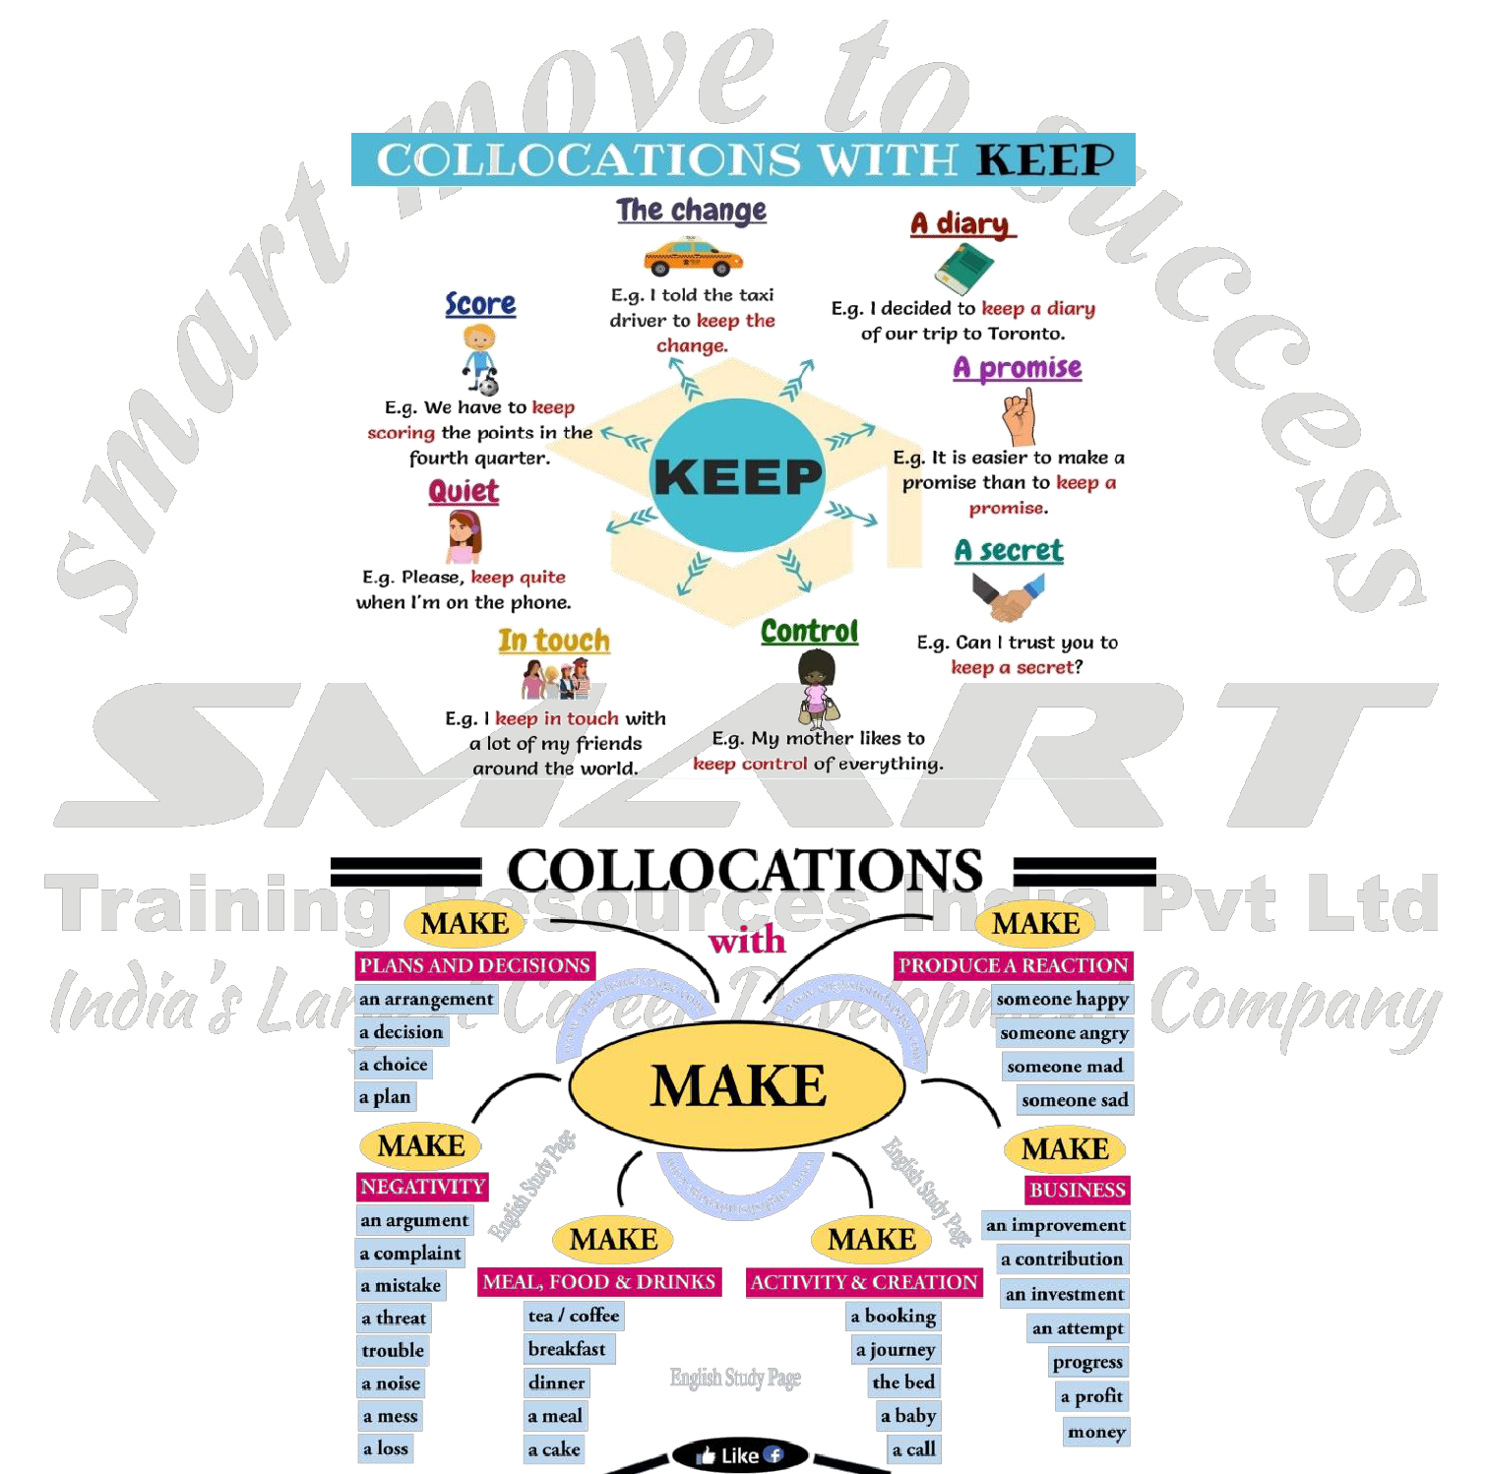

Did you know there are even certain English words that go hand-in-hand?

These words are called *collocations*. You’ll always find them hanging out together like best friends.



Page **25** of **75**

**VERBAL ABILITY**



**HSEM2BTECHSTANDARDVA1119**

**COLLOCATIONS vs Phrasal Verbs**

Collocations are words that are generally used together.

For example,

* commit a crime
* make a mistake
* distant memory
* break a record
* bunch of flowers
* fast food

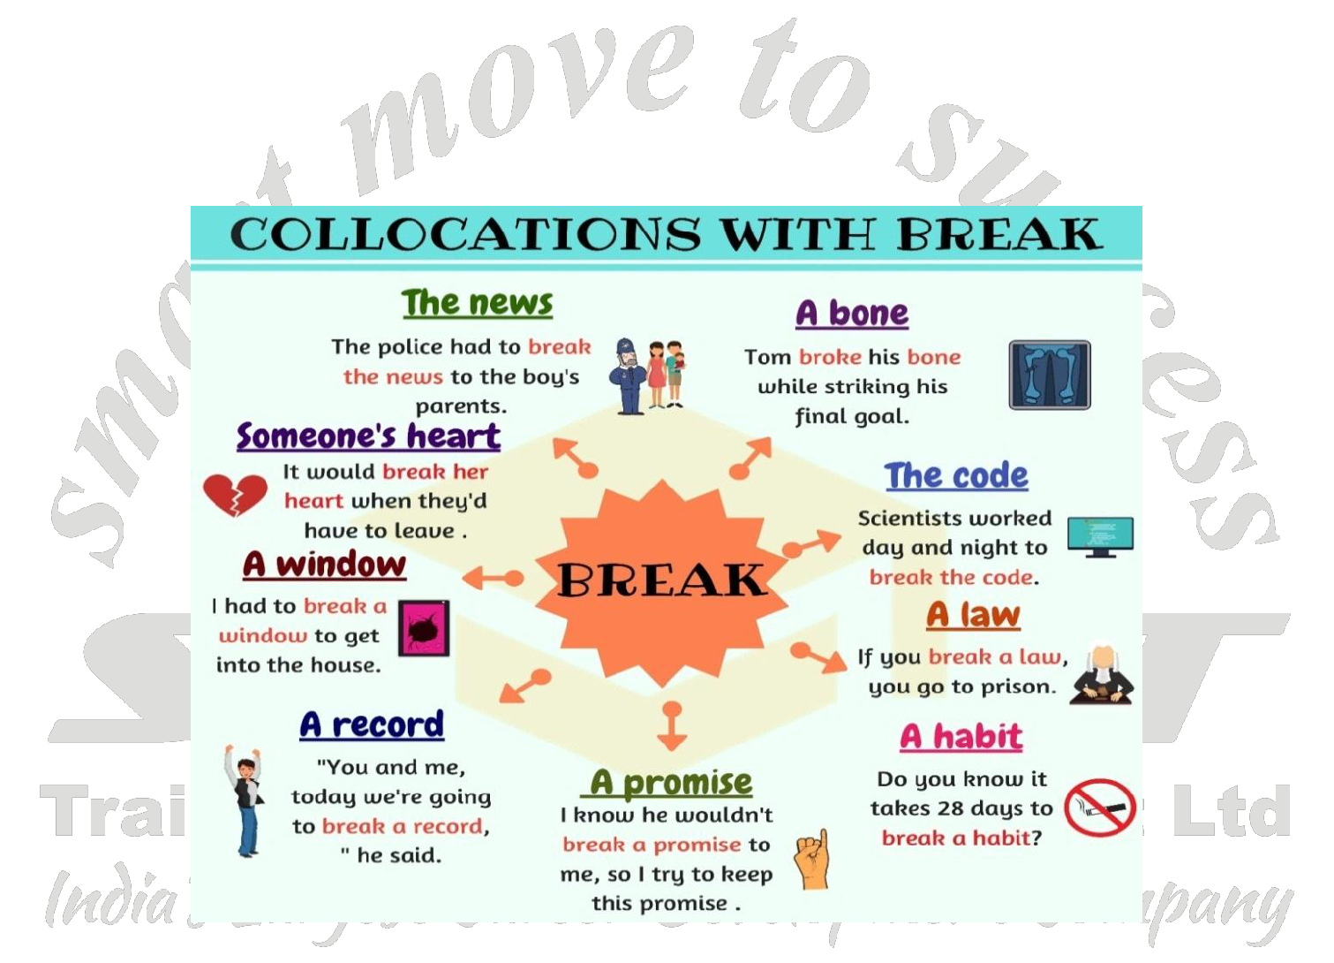

It would sound strange if you said **’make a crime’, ’do a mistake’, ’remote memory’, ’knock a record’, ’pack of** **flowers’** or **’quick food’**. These words don’t collocate with each other (don’t sound correct together).

**PHRASAL VERBS**

Phrasal verbs are **verb+preposition** combinations, so they are usually two-word expressions (sometimes more).

For example, ’look + after’, ’put off’, ’take + up’ or ’put + up with’.

The meaning of a phrasal verb is often very different from the original verb:

* *She’s* ***looking after*** *the children. (She is taking care of the children.)*
* *They’ve* ***put off*** *the meeting. (They’ve postponed the meeting.)*
* *Greg’s* ***taken up*** *golf. (Greg’s started playing golf.)*



Page **26** of **75**

**VERBAL ABILITY**



**HSEM2BTECHSTANDARDVA1119**



 **GERUNDS**

**What is a Gerund?**

* A gerund is a noun made from a verb by adding "-ing.”
* Gerunds function as nouns. Thus, gerunds will be subjects, subject complements, direct objects, indirect objects, and objects of prepositions.

**Functions of a Gerund**

**Function**

**Example sentence**

**Subject**

***Hiking***

*can be a relaxing and rewarding activity.*

**Complement**

*What I really like is*

***travelling*** *to other countries.*

**Object of a verb**

*Jill suggested* ***going*** *for a drink.*

**Object of a preposition**

*He rushed out of the room without*

***saying*** *a word.*

**Object of a prepositional verb**

*Could you give up* ***smoking****?*

**Part of a compound noun**

*We had no* ***drinking*** *water left.*

**Examples**

1. Since Francisco was five years old, **swimming** has been his passion.
   * Swimming = **subject** of the verb has been.
2. Francisco's first love is **swimming**.
   * Swimming = **subject complement** of the verb is.



Page **27** of **75**

**VERBAL ABILITY**



**HSEM2BTECHSTANDARDVA1119**

**Examples**

* Francisco enjoys ***swimming*** more than spending time with his girlfriend Diana.
* ***Swimming*** = direct object of the verb ***enjoys***.
* Francisco gives ***swimming*** all of his energy and time.
* ***Swimming*** = indirect object of the verb ***gives***.
* When Francisco wore dive fins to class, everyone knew that he was devoted to ***swimming***.
* ***Swimming*** = object of the preposition ***to***.

**Gerunds**

* Gerunds can be made negative by adding "not."



**Examples:**

* He enjoys **not working**.
* The best thing for your health is **not smoking**.

**Rules of Gerunds**

1. **Subject = Gerund**

When you need an action as a subject, use a gerund.

* + **Reading** is my favorite hobby.
  + **Learning** English has improved my confidence.

1. **Preposition + Gerund**

After a preposition, use a gerund. This is true for prepositions that are part of phrasal verbs, too.

* + I thought about **calling** my grandma, but I was too tired.
  + Are you planning on **going** to the party**?**

1. **Verb + Gerund**

A gerund or an infinitive can be used after a main verb. It depends on the verb, and there isn’t an easy rule for this case.

Memorizing the most common verbs that take a gerund, such as *advise, avoid, enjoy, finish, practice, quit,* and *suggest,* is helpful.

* + My teacher advised **studying** for the quiz.
  + They enjoy **making** crafts in class.

**Gerunds Vs Present Participle**

* Gerunds function as a noun, while present participle functions as adjectives and Present continuous tense.

**Compare:**

* He kept me **waiting.** (Waiting – present participle)
* I don’t like **waiting.** (Here the –ing form waiting is the object of the verb **like** and hence it acts like a noun. It is therefore a gerund.)
* After **playing** for an hour, he went home. (Playing – present participle)
* **Playing** is good for health. (Here the–ing form playing is the subject of the verb **is** and hence it acts like a noun.It is therefore a gerund.)



Page **28** of **75**

**VERBAL ABILITY**



**HSEM2BTECHSTANDARDVA1119**

**Exercise 2**

**Directions for Q15 to Q19:** Say whether the–ing forms given in the following sentences are gerunds or present participles.

1. **Telling** lies won’t help anyone.
2. She was punished for **coming** late.
3. Children learn **reading and writing** at school.
4. **Coming** events cast their shadow.
5. He left the tap **running.**



**Exercise 3**

1. We decided ______________ ***(run)*** through the forest.
2. I learned ______________ ***(ride)*** the bike at the age of 5.
3. She doesn't mind ______________ ***(work)*** the night shift.
4. The man asked me how ______________ ***(get)*** to the airport.
5. I can't imagine Peter ______________ ***(go)*** by bike.
6. Are you thinking of ______________ ***(visit)*** London?
7. He agreed ______________ ***(buy)*** a new car.
8. The teacher expected Sarah ______________ ***(study)*** hard.
9. I look forward to ______________ ***(see)*** you at the weekend.
10. The question is easy ______________ ***(answer)***.



Page **29** of **75**

**VERBAL ABILITY**



**HSEM2BTECHSTANDARDVA1119**

**Exercise 4**

1. A wedding involves ______________ (negotiate) with everyone in the family.
2. He denies ______________ (steal) the money.
3. He claims ______________ (be) a millionaire but I don't believe him.
4. I expect ______________ (be) there about seven.
5. Julia reported ______________ (see) the boys to the police.
6. The teenager refused ______________ (go) on holiday with his parents.
7. I understand ______________ (be) late once or twice, but every day is too much!
8. That criminal deserves ______________ (get) a long sentence.
9. We arranged ______________ (meet) at four but at four thirty she still hadn't arrived.
10. She mentioned ______________ (go) to the cinema, but I don't know what she decided to do in the end.



 **TENSES**

**Tenses**

Tense is a category of grammar used to show the timing of what we are talking about. In grammar, the word tense means time.

English has two true tenses: past and present.

* For example "I went to the zoo yesterday" (past tense) and "I am calling you from the zoo" (present tense).
* Future tense, as in "I am going to the zoo next week", is really a sub-category, but still belongs to the concept of tense.
* So we can see that the importance of tenses is to let the reader or hearer know when things happen.

**PRESENT SIMPLE**

Tense and aspect, although they are two different categories, always appear together.

With reference to tense and aspect, we can speak about the following structures in practical usage. All English Tenses with Examples!

(Note: progressive aspect is often called continuous.)

(present tense + common aspect)

FORM

Affirmative: Subject + Base Form of the Verb

Note: for 3rd Person Singular (he/ she/ it) add ‘s’ to the base form

*I/ You/ We/ They work in a bank.*

*He/ She works in a bank.*

**Negative: Subject + don’t/ doesn’t + Base Form of the Verb**

***I/ You/ We/ They don’t (do not) work.***

***He/ She/ It doesn’t (does not) work.***



Page **30** of **75**

**VERBAL ABILITY**



**HSEM2BTECHSTANDARDVA1119**

**Interrogative: Question Word + do/does + Subject + Base Form of the Verb**

***Where do I/ you/we/they work?***

***Where does he/ she work?***

1. **Usual, regular action:**
   * *I usually* ***go*** *fishing at weekends.*
   * *I* ***don’t go*** *fishing at weekends.*
   * ***Do*** *I* ***go*** *fishing at weekends?*
   * *You always* ***know*** *the answer.*
   * *You* ***don’t*** *always* ***know*** *the answer.*
   * ***Do*** *you always* ***know the*** *answer?*
   * *She never* ***adds*** *milk to her tea.*
   * *She* ***doesn’t add*** *milk to her tea.*
   * ***Does*** *she ever* ***add*** *milk to her tea?*
2. **General existence; stating a fact:**
   * *An ostrich* ***has*** *two legs.*
   * *A rabbit* ***doesn’t have*** *two legs.*
   * *How many legs* ***does*** *a spider have?*
   * *The earth* ***goes*** *round the sun.*
   * *The sun* ***doesn’t go*** *round the earth.*
   * ***Does*** *the moon* ***go round*** *the earth?*
3. **Dramatic narrative (theatre, sports, etc. events):**
   * *Johnson* ***takes*** *the ball, he* ***bounces*** *it to the floor, then he* ***throws*** *and* ***scores*** *two points.*
4. **Timetables:**
   * *The train* ***leaves*** *at half past four.*
   * *The train* ***doesn’t******leave*** *at five.*
   * *What time* ***does*** *the train leave?*
   * *The course* ***starts*** *on 1 July.*
   * The course **doesn’t start** in June.
   * When **does** the course start?



**PRESENT PROGRESSIVE**

(present tense + progressive aspect)

FORM

Affirmative: Subject + BE + Verb-ING

*You are cooking.*

Negative: Subject + BE not + Verb-ING

*You aren’t (are not) cooking.*

Interrogative: Question Word + BE + Subject + Verb-ING

*What are you cooking? / Are you cooking?*



Page **31** of **75**

**VERBAL ABILITY**

**PRESENT PROGRESSIVE USE**

1. **Action happening now:**
   * *I’m watching a film on TV.*
   * *I‘m not watching a film.*
   * *Am I watching a film?*
   * *Watch out, a car’s coming.*
   * *It isn’t coming./Is it coming?*
   * *The boys are sleeping upstairs.*
   * *The boys aren’t sleeping upstairs.*
   * *Are the boys sleeping upstairs?*
2. **Action happening about this time, but not necessarily now:**
   * *He****‘s studying*** *Spanish and German.*
   * *He****‘s not studying*** *French.*
   * *What languages* ***is*** *he studying?*
   * *They****‘re going*** *to a business course.*
   * *They* ***aren’t going*** *to a cooking course.*
   * *What course* ***are*** *they* ***going*** *to?*
   * *You****‘re visiting*** *museums while you’re here.*
   * *You****‘re not visiting*** *factories.*
   * ***Are*** *you visiting museums in our city?*
3. **Definite arrangement in the near future:**
   * *I****‘m travelling*** *to Paris tomorrow.*
   * *I****‘m not travelling*** *to Paris tomorrow.*
   * ***Am*** *I* ***travelling*** *to Paris tomorrow?*
   * *My son* ***is taking*** *his girlfriend to dinner tonight.*
   * *My son* ***isn’t taking*** *his girlfriend to dinner tonight.*
   * ***Is*** *he* ***taking*** *his girlfriend to dinner tonight?*
   * *You****‘re going*** *to Italy on holiday this year, aren’t you?*
   * *You* ***aren’t going*** *to Greece.*
   * *Where are you* ***going*** *on holiday this year?*



**PAST SIMPLE**

(past tense + common aspect)

FORM

Affirmative: Subject + Verb in Past Simple (2nd form)

*I/ You/ He/ She/ It/ We/ They lived in London ten years ago.*

Negative: Subject + didn’t (did not) + Base Form of the Verb

*I/ You/ He/ She/ It/ We/ They didn’t like the film.*

Interrogative: Question Word + did + subject + Base Form of the Verb

*Where did I/ you/ he/ she/ it/ we/ they meet Richard?*



**HSEM2BTECHSTANDARDVA1119**



Page **32** of **75**

**VERBAL ABILITY**

**PAST SIMPLE USE**

1. **Actions, events in the past:**
   * *Mother* ***went*** *to work on Tuesday.*
   * *Mother* ***didn’t******go*** *to work on Tuesday.*
   * ***Did*** *Mother* ***go to*** *work on Tuesday?*
   * *You* ***did*** *the shopping this morning.*
   * *You* ***didn’t******do*** *the shopping this morning.*
   * *Where* ***did you do*** *the shopping this morning?*

**PAST PROGRESSIVE**

(past tense + progressive aspect)



FORM

1. Affirmative: Subject + was/ were + Verb-ING
   * *I/ He/ She was having a shower when you called.*
   * *We/ You/ They were watching TV when Bob arrived.*
2. Negative: Subject + wasn’t (was not)/ weren’t (were not) + Verb-ING
   * *I/ He/ She wasn’t having a shower when you called.*
   * *We/ You/ They weren't’ watching TV when Bob arrived.*
3. Interrogative: Question word + was/ were + Verb-ING
   * *What were you doing when Bob arrived?*
   * *What was she doing when you called?*

**PAST PROGRESSIVE USE**

**Action in progress in the past:**

* *I* ***was working*** *in the garden when my sister arrived.*
* *I* ***wasn’t******working*** *in the garden when my sister arrived.*
* ***Was*** *I* ***working*** *in the garden when my sister arrived?*
* *We* ***were watching*** *a film at ten last night.*
* *We* ***weren’t******watching*** *a film at ten last night.*
* ***Were*** *we* ***watching*** *film at ten last night?*
* *She* ***was playing*** *with the kids from eight to nine.*
* *She* ***wasn’t******playing*** *with the kids from eight to nine.*
* *Who* ***was*** *she* ***playing*** *with?*

**PRESENT PERFECT SIMPLE**

(present perfect tense + common aspect)

FORM

1. Affirmative: Subject + have/ has + Past Participle (3rd Form of the Verb)
   * *I/ You/ We/ They have finished the letter.*
   * *He/ She has finished the letter.*



**HSEM2BTECHSTANDARDVA1119**



Page **33** of **75**

**VERBAL ABILITY**

1. Negative: Subject + haven’t (have not)/ hasn’t (has not) + Past Participle
   * *I/ You/ We/ They haven’t finished the letter.*
   * *He/ She hasn’t finished the letter.*
2. Interrogative: Question Word + have/ has + Past Participle
   * *Have I/ you/we/ they finished the letter?*
   * *Has he/she finished the letter?*

**PRESENT PERFECT SIMPLE USE**

1. **Action with a result:**
   * *Sorry, I****‘ve******parked*** *at the wrong place.*
   * *I* ***haven’t******parked*** *at the wrong place.*
   * ***Have*** *I parked at the wrong place?*
   * *You****‘ve*** *(already)* ***printed*** *the letters.*
   * *You* ***haven’t******printed*** *the letters (yet).*
   * ***Have*** *you printed the letters (yet)?*
   * *We****‘ve*** *(already)* ***done*** *the rooms.*
   * *We* ***haven’t******done*** *the rooms yet.*
   * ***Have*** *we* ***done*** *the rooms (yet)?*
2. **Action in incomplete time:**
   * *Our friends* ***have visited*** *us four times this summer.*
   * *Our friends* ***haven’t******visited*** *us this summer.*
   * *How many times* ***have*** *our friends* ***visited*** *us this summer?*
   * *I****‘ve******been*** *to the cinema a lot lately.*
   * *I* ***haven’t******been*** *to the cinema lately.*
   * ***Have*** *I* ***been*** *to the cinema lately?*
3. **Action in the past without saying when:**
   * *Jane* ***has*** *already* ***seen*** *the movie.*
   * *Jane* ***has*** *never* ***seen*** *the movie.*
   * ***Has*** *Jane ever s****een*** *the movie?*
   * *You* ***have*** *already* ***swum*** *in this lake.*
   * *You* ***haven’t******swum*** *in this lake yet.*
   * ***Have*** *you ever swum in this lake?*



**PRESENT PERFECT PROGRESSIVE**

(present perfect tense + progressive aspect)

FORM

1. Affirmative: Subject + have/ has been + Verb-ING
   * *I/ you/ We/ They have been learning English for a year.*
   * *He/ She has been learning English for a year.*



**HSEM2BTECHSTANDARDVA1119**



Page **34** of **75**

**VERBAL ABILITY**



**HSEM2BTECHSTANDARDVA1119**

1. Negative: Subject + haven’t/hasn’t been + Verb-ING
   * *I/ You/ We/ They haven’t been playing tennis for a long time.*
   * *He/ She hasn’t been playing tennis for a long time.*
2. Interrogative: Question Word + have/ has + Subject + been Verb-ING
   * *How long have I/ you/ we/ they been learning English?*
   * *How long has he/ she been learning English?*

**PRESENT PERFECT PROGRESSIVE USE**

**Action beginning in the past and still continuing (with the progress emphasized):**

* *They****‘ve******been staying*** *in this hotel for ten days.*
* *They* ***haven’t******been staying*** *in this hotel for ten days.*
* ***Have*** *they* ***been staying*** *in this hotel for ten days?*
* *He* ***has been mowing*** *the lawn all this morning.*
* *He* ***hasn’t******been mowing*** *the lawn all this morning.*
* *How long* ***has*** *he* ***been mowing*** *the lawn?*
* *You****‘ve******been missing*** *classes lately.*
* *You* ***haven’t******been coming*** *to class lately.*
* *What* ***have*** *you* ***been doing*** *lately?*



**PAST PERFECT SIMPLE**

**(past tense + common aspect)**

**FORM**

**Affirmative: Subject + had + Past Participle**

***I/ You/ He/ She/ We/ They had already met Sarah before the***

***party.***

**Negative: Subject + hadn’t (had not) + Past Participle**

***I/ You/ He/ She/ We/ They hadn’t met Sarah before the party.***

**Interrogative: Question Word + had + Subject + Past Participle**

***Had I/ you/ he/ she/ we/ they met Sarah before the party?***

**PAST PERFECT SIMPLE USE**

**Action in the past before another:**

* *She said she* ***had written*** *three letters the day before.*
* *She said she* ***hadn’t******written*** *any letters the day before.*
* *How many letters* ***had*** *she* ***written*** *the day before?*
* *They* ***had lived*** *in York before they moved to Liverpool.*
* *They* ***hadn’t******lived*** *in York before they moved to Liverpool.*
* *Where* ***had*** *they* ***lived*** *before they moved to Liverpool?*



Page **35** of **75**

**VERBAL ABILITY**



**HSEM2BTECHSTANDARDVA1119**

* *You****‘d******locked*** *the door before you left.*
* *You* ***hadn’t******locked*** *the door before you left.*
* ***Had you locked*** *the door before you left?*

**PAST PERFECT PROGRESSIVE**

(past perfect tense + progressive aspect)

FORM

Affirmative: Subject + had been + Verb-ING

*I/ You/ He/ She/ We/ They had been living in German for years before moving here.*



Negative: Subject + hadn’t been + Verb-ING

*I/ You/ He/ She/ We/ They hadn’t been living in Germany for a long time before moving here.*

Interrogative: Question Word + had + Subject + been Verb-ING

*How long had I/ you/ he/ she/ we/ they been living in Germany before moving here?*

**PAST PERFECT PROGRESSIVE USE**

**Action in the past before another (with the progress emphasized):**

* *He said he* ***had been mowing*** *the lawn all that morning.*
* *He said he hadn’t been mowing the lawn all that morning.*
* *How long had he been moving the lawn when you met him?*
* *They* ***had been working*** *for the same company for a long time before they changed jobs.*
* *They hadn’t been* ***working*** *for the same company for a long time before they changed jobs.*
* *Had they been* ***working*** *for the same company for a long time before they changed jobs?*
* *They had been* ***living*** *in York before they moved to Liverpool.*
* *They hadn’t been* ***living*** *in York before they moved to Liverpool.*
* *How long* ***had*** *they* ***been living*** *in York before they moved to Liverpool?*

**FUTURE SIMPLE**

(future tense + common aspect)

FORM

Affirmative: Subject + Will + Base Form of the Verb

*I/ You/ He/ She/ We/ They will see Jane when she comes back from India.*

Negative: Subject + Won’t (will not) + Base Form of the Verb

*I/ You/ He/ She/ We/ They won’t see Jane when she comes back from India.*

Interrogative: Question Word + Will + Subject + Base Form of the Verb

*Will I/ you/ he/ she/ we/ they see Jane when she comes back from India?*

**FUTURE SIMPLE USE**

**Fact, action or event in the future:**

* *I* ***will be*** *thirty years old next year.*
* *I* ***won’t******be*** *thirty years old again.*
* ***Will*** *I* ***be*** *thirty years old again?*



Page **36** of **75**

**VERBAL ABILITY**

* *We****‘ll******meet*** *them at the station at six.*
* *We* ***won’t******meet*** *them at the station.*
* *Where* ***will*** *we meet them?*
* *You****‘ll******cross*** *the channel by ferry.*
* *You* ***won’t******cross*** *the channel.*
* *How* ***will*** *you* ***cross*** *the channel?*

**FUTURE PROGRESSIVE**

(future tense + progressive aspect)

FORM



Affirmative: Subject + Will Be + Verb-ING

*I/ You/ He/ She/ We/ They will be having fun at the party.*

Negative: Subject + Won’t Be + Verb-ING

*I/ You/ He/ She/ We/ They won’t be having fun at the party.*

Interrogative: Question Word + Will + Subject + Be Verb-ING

*Will I/ you/ he/ she/ we/ they be having fun at the party?*

**FUTURE PROGRESSIVE USE**

**Action in progress at a given time of the future:**

* *This time tomorrow we* ***will be flying*** *to Los Angeles.*
* *We* ***won’t******be flying*** *to New York.*
* *Where* ***will*** *we* ***be flying****?*
* *You****‘ll******be doing*** *housework with me at six tomorrow.*
* *You* ***won’t******be playing*** *football.*
* *What will you* ***be doing*** *at six tomorrow?*
* *I****‘ll******be playing*** *tennis from seven to nine.*
* *I* ***won’t******be playing*** *tennis at six.*
* *When* ***will*** *I* ***be playing*** *tennis?*

**FUTURE PERFECT SIMPLE**

(future perfect tense + common aspect)

FORM

Affirmative: Subject + Will Have + Past Participle

*I/ You/ He/ She/ We/ They will have met Dora’s husband by this time tomorrow.* Negative: Subject + Won’t Have + Past Participle

*I/ You/ He/ She/ We/ They won’t have met Dora’s husband by this time tomorrow.*



**HSEM2BTECHSTANDARDVA1119**



Page **37** of **75**

**VERBAL ABILITY**



**HSEM2BTECHSTANDARDVA1119**

Interrogative: Question Word + Will + Subject + Have + Past Participle

*Will you have met Dora’s husband by this time tomorrow?*

**FUTURE PERFECT SIMPLE USE**

**Action completed by a given time of the future:**

* *I* ***will have done*** *this work by the end of next week.*
* *I* ***won’t******have done*** *this work by the end of next week.*
* ***Will*** *I* ***have done*** *this this work by the end of next week?*
* *They****‘ll******have arrived*** *by the time we return.*
* *They* ***won’t******have arrived*** *by the time we return.*
* ***Will*** *they* ***have arrived*** *by the time we return?*
* *She* ***will have taken*** *three exams by next Tuesday.*
* *She* ***won’t******have taken*** *any exams by next Tuesday.*
* *How many exams* ***will*** *she* ***have taken*** *by next Tuesday?*



**FUTURE PERFECT PROGRESSIVE**

(future perfect tense + progressive aspect)

FORM

Affirmative: Subject + Will Have Been + Verb-ING

*I/ You/ He/ She/ We/ They will have been working with John for ten years next week.*

Negative: Subject + Won’t Have Been + Verb-ING

*I/ You/ He/ She/ We/ They won’t have been working with John for ten years next week.*

Interrogative: Question Word + Will + Subject + Have Been + Verb-ING

*How long will I/ you/ he/ she/ we/ they have been working with John next week?*

**FUTURE PERFECT PROGRESSIVE USE**

**Action completed by or still in progress at a given time in the future (with the progress emphasized):**

* *We* ***will have been staying*** *here for a week tomorrow.*
* *We* ***won’t******have been staying here*** *for a week tomorrow.*
* *How long* ***will*** *we* ***have been staying*** *here?*
* *You* ***will have been living*** *here for thirty years by this time next year.*
* *You* ***won’t******have been living*** *here for thirty years by this time next year*
* *How long* ***will*** *you* ***have been living here*** *by this time next year?*
* *I****‘ll******have been playing*** *the guitar for ten years by next year.*
* *I* ***won’t******have been playing the*** *guitar for ten years by next year.*
* *How long* ***will*** *I* ***have been playing*** *the guitar?*



Page **38** of **75**

**VERBAL ABILITY**



**HSEM2BTECHSTANDARDVA1119**

**Ready reckoner for reference**

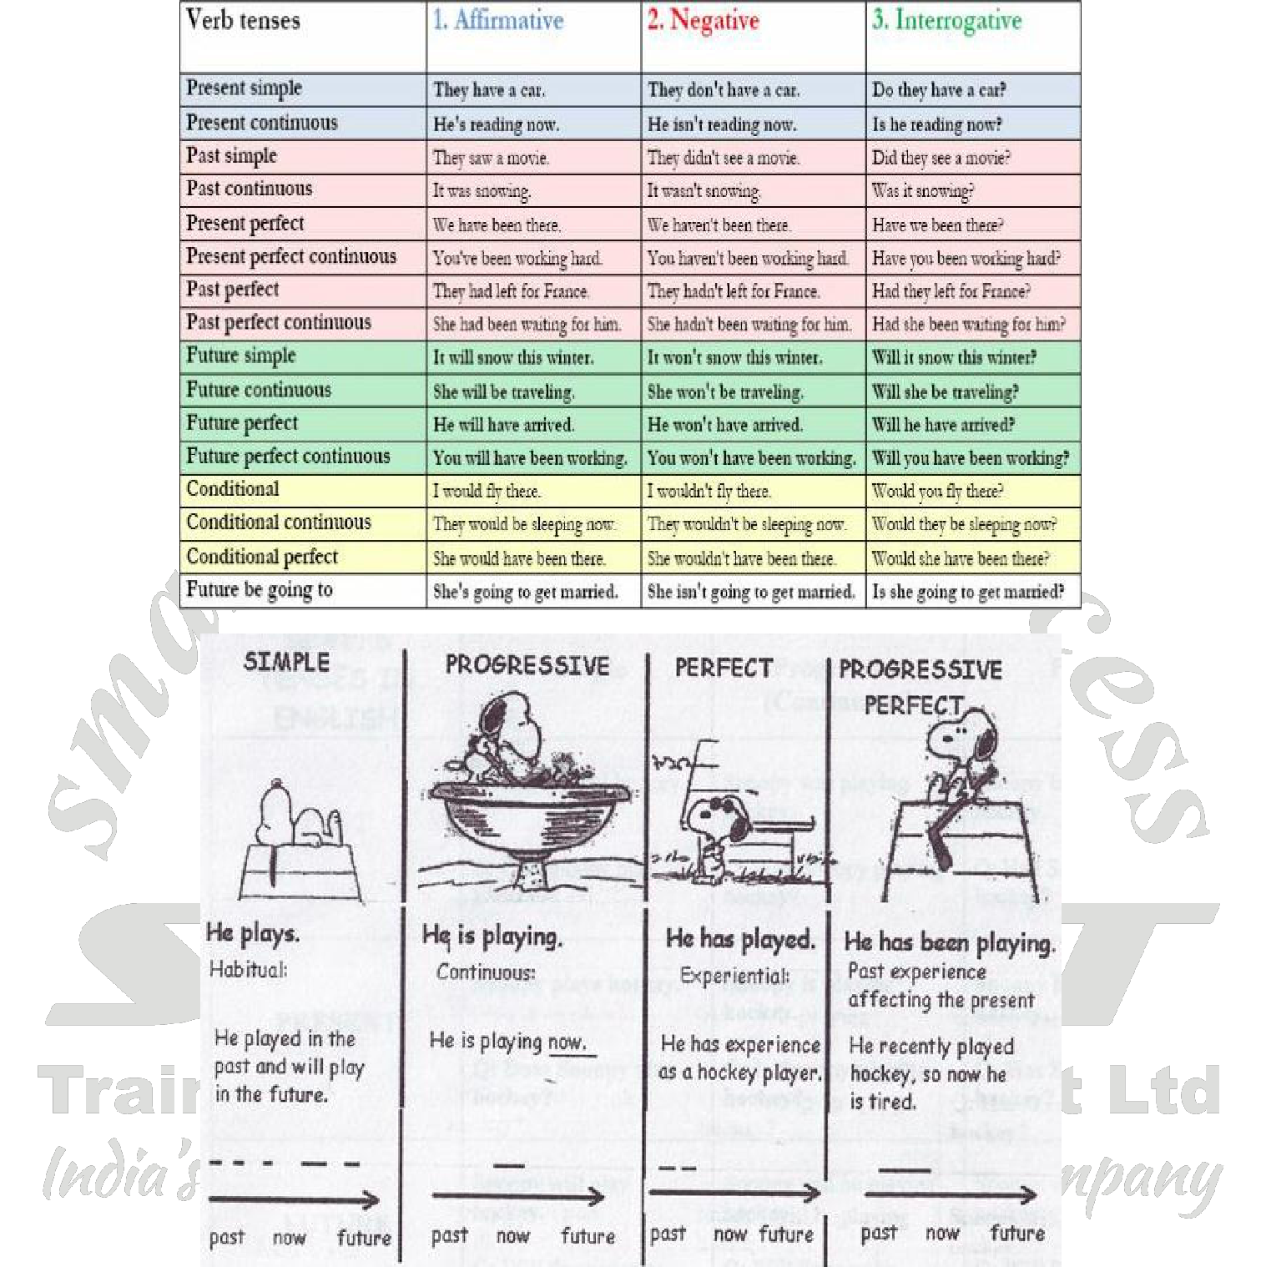

**Exercise 5**

**Complete the blanks using the verbs in the correct tense (simple present or present progressive)**

1. Look! Sara ____________ (go) to the movies.
2. On her right hand, Sara ____________ (carry) her handbag.
3. The handbag ____________ (be) very beautiful.
4. Sara usually ____________ (put) on black shoes but now she ____________ (wear) white trainers.
5. And look, she ____________ (take) an umbrella because it ____________ (rain).



Page **39** of **75**

**VERBAL ABILITY**



**HSEM2BTECHSTANDARDVA1119**

**Exercise 6**

**Use the verbs in the correct tense (simple past or past perfect)**

1. When he (wake up) ____________, his mother (already/prepare) ____________ breakfast.
2. We (go) ____________ to London because our friends (invite) ____________ us.
3. He (hear) ____________ the news, (go) ____________ to the telephone and (call) ____________ a friend.
4. When she (start) ____________ learning English she (already /learn) ____________ French.
5. Jane (already/type) ____________ three pages when her computer (crash) ____________.
6. By the time the doctor (arrive) ____________ at the house the patient (die) ____________.
7. Before that day we (never/think) ____________ of traveling to Japan.
8. I (know) ____________ him a long time before I (meet) ____________ his family.
9. They (not/know) ____________ where to meet because nobody (tell) ____________ them.
10. It (be) ____________ cloudy for days before it (begin) ____________ to rain.



**Exercise 7**

**Use the verbs in the correct tense (simple past or present perfect).**

1. I (just / finish) ______________ my homework.
2. Mary (already / write) ______________ five letters.
3. Tom (move) ______________ to his home town in 1994.
4. My friend (be) ______________ in Canada two years ago.
5. I (not / be) ______________ to Canada so far.
6. But I (already / travel) ______________ to London a couple of times.
7. Last week, Mary and Paul (go) ______________ to the cinema.
8. I can't take any pictures because I (not /buy) ______________ a new film yet.
9. (they / spend) ______________ their holidays in Paris last summer?
10. (you / ever / see) ______________ a whale?

**Exercise 8**

**Use the verbs in the correct tense (Simple Past or Past Progressive).**

1. The receptionist (welcome) ______________ the guests and (ask) ______________ them to fill in the form.
2. The car (break) ______________ down and we (have) ______________ to walk home.
3. The boys (swim) ______________ while the girls (sunbath) ______________.
4. My father (come) ______________ in, (look) ______________ and (tell) ______________ me to tidy up my room.
5. While one group (prepare) ______________ dinner the others (collect) ______________ wood for the campfire.



Page **40** of **75**

**VERBAL ABILITY**



**HSEM2BTECHSTANDARDVA1119**

**Exercise 9**

**Use the verbs in the correct tense (simple future or future perfect)**

1. Tomorrow I think I (start) ______________ my new project.
2. I (finish) ______________ it by the end of this month.
3. The teacher (probably/assign) ______________ a test to his students next Monday.
4. He (correct) ______________ it by the end of next week.
5. My friend (certainly/get) ______________ a good mark.



**Exercise 10**

**Present Tense – Simple or progressive- Fill up the blanks.**

1. They normally ______________ lunch at two. (have)
2. Are ______________ in Paris this week? (you work)
3. You ______________ new clothes every Saturday! (buy)
4. John ______________ a difficult time at the university this year. (have)
5. Do ______________ those men at the door? – They ______________ at us very strangely (you see, look)

**Exercise 11**

**Present Tense – Simple or Progressive: Fill up the blanks.**

1. It often ______________ in Ireland. (rain)
2. ______________ there now (rain)?
3. Susan ______________ to her parents every Sunday night. (write)
4. Stop at once! You ______________ the flowers every time the ball ______________ in the garden. (break, land)
5. She normally ______________ in Northbridge but she ______________ with friends at the moment. (live, stay)

**Exercise 12**

**Past Tense – Simple or progressive. Fill up the blanks.**

1. It ______________ (rain) when we ______________ (come) out of the shopping centre.
2. It ______________ (happen) very quickly. The car ______________ (come) out of the side road and then the van

______________ (drive) into the back of it.

1. I ______________ (be) ill last week.
2. He ______________ (break) his leg when he ______________ (ski).
3. I ______________ (look) out of the window and saw that people ______________ (walk) in the park.
4. When ______________ (you buy) the car? – I ______________ (buy) it a few years ago.



Page **41** of **75**

**VERBAL ABILITY**



**HSEM2BTECHSTANDARDVA1119**

**Exercise 13**

**Fill in the blanks with the Present Perfect form of the verb given in the bracket.**

1. The earth ______________ here for billions of years. (be)
2. We ______________ cards for the last few hours. (play)
3. We ______________ problems with our new car recently. (have)
4. ______________ on anything interesting lately? (you work)
5. Cuba ______________ a socialist country since 1959. (be)
6. ______________ an important fight? (the boxer, ever, win)



**Exercise 14**

**Past or Present Perfect Tense – Simple form**

1. The weather ______________ (be) awful in the past few days.
2. We ______________ (wash) the dishes. They’re clean now.
3. ______________ (your course, start) yet?
4. Emma ______________ (pack) her suitcase last night.
5. They ______________ (close) the factory. – Really? When ______________ (that happen)?
6. Shall we play tennis? We ______________ (not play) since we were children.

**Exercise 15**

**Past or Past Perfect Tense – Simple: Fill in the correct form.**

1. Mary ______________ (give) me Tony's address before she left.
2. When the boys arrived at the cinema, the film ______________ (already, start).
3. Before we reached the station we saw that we ______________ (lose) our way.
4. Mum asked me why I ______________ (not tidy) up my room.
5. Alan watched TV after he ______________ (have) lunch.
6. The sun ______________ (shine) yesterday after it ______________ (be) cold for many weeks.

**Exercise 16**

**Frame sentences using the tense mentioned in the brackets.**

1. We –able - climb – mountain (past simple)
2. What – you – think –of England? (present simple)
3. We – learn – the whole night. (past perfect progressive)
4. Where – he – go? (present perfect simple)
5. How often – you – go – dentist? (present simple)
6. We – walk down – street (past progressive)
7. Jane – not able to – walk – after the accident (past simple)
8. She – wait – for an hour (present perfect progressive)



Page **42** of **75**

**VERBAL ABILITY**



**HSEM2BTECHSTANDARDVA1119**

**Rules that govern the tenses as follows**

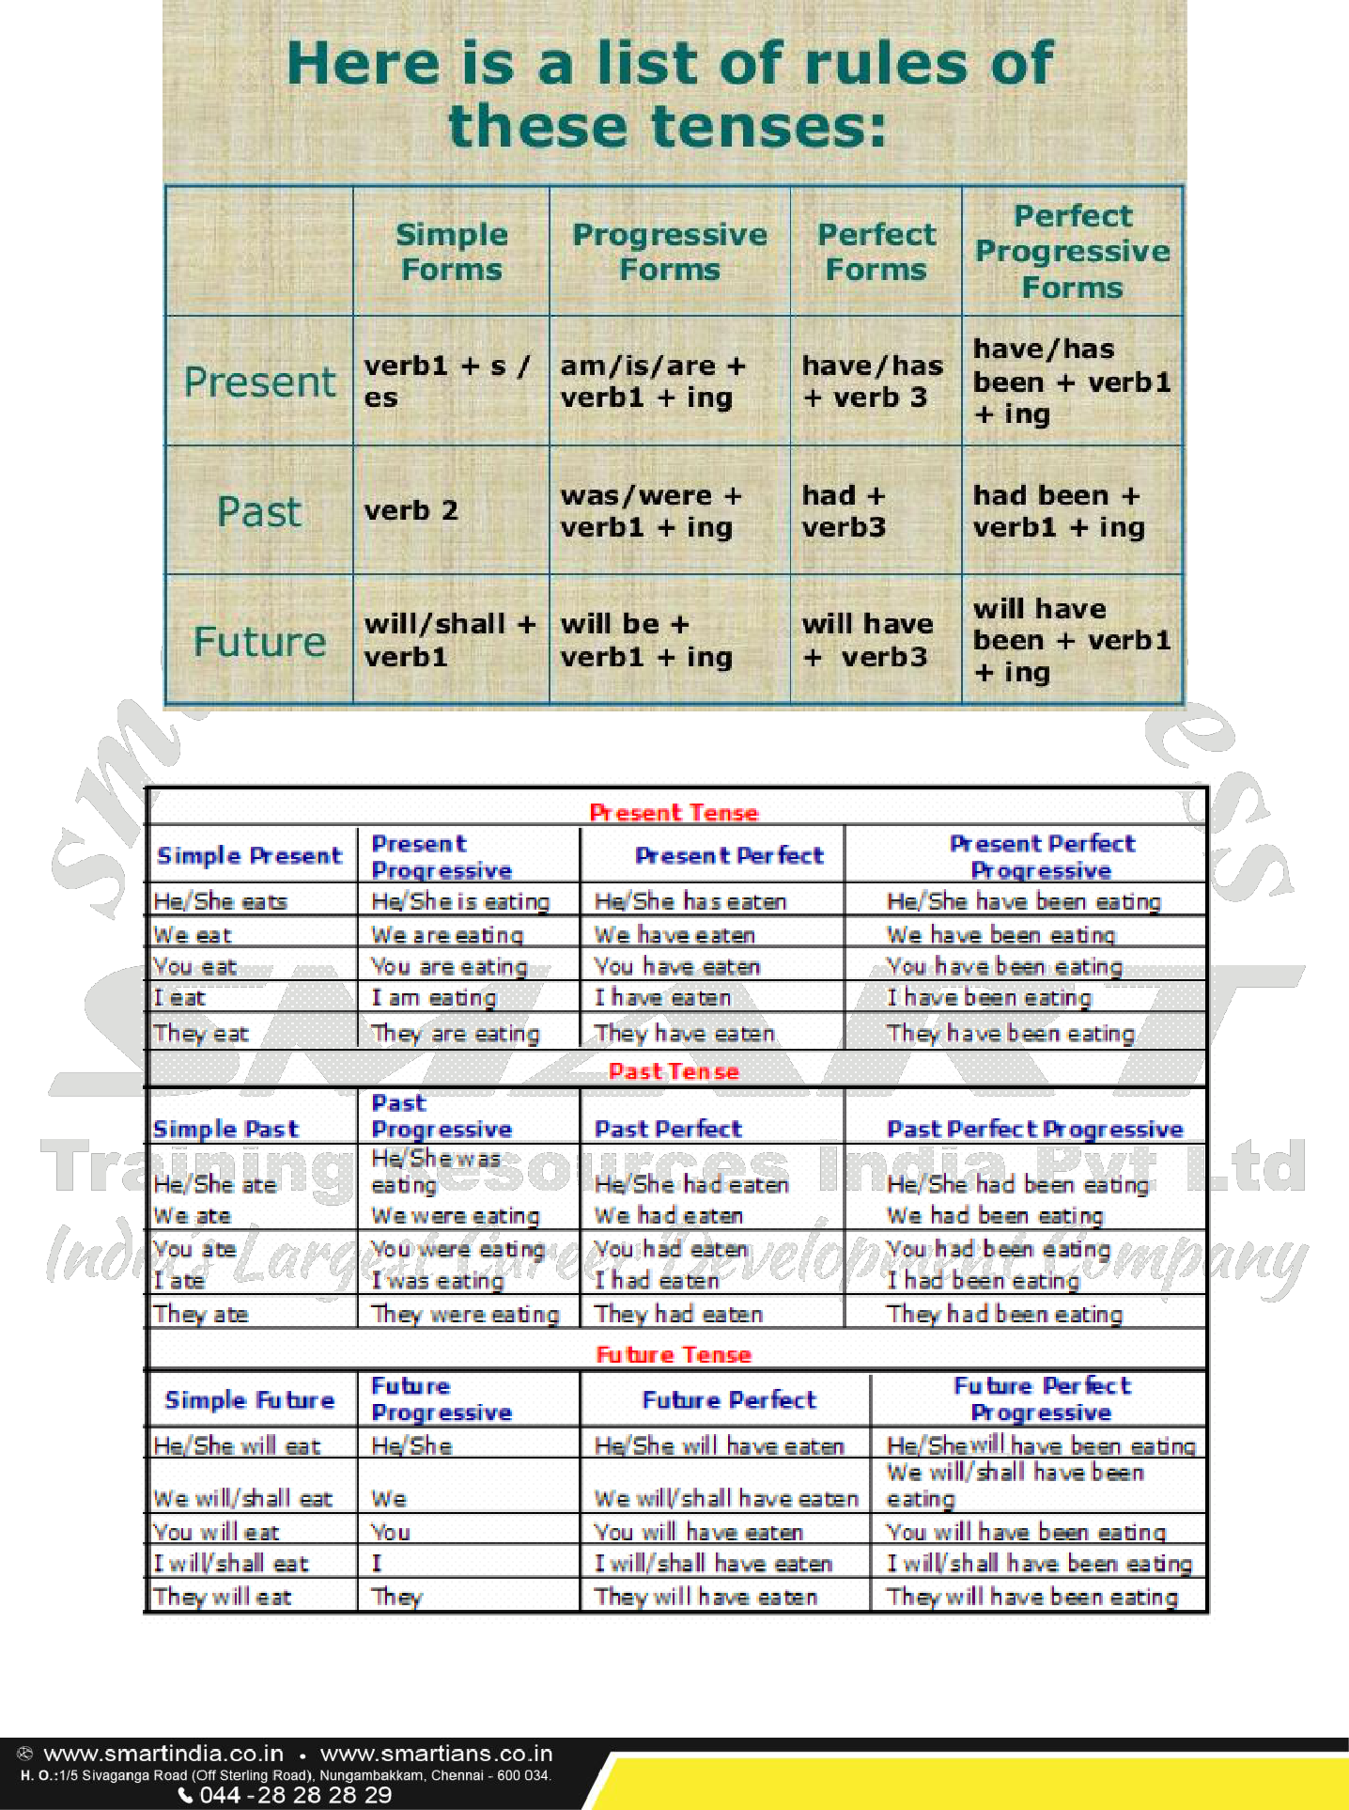

Page **43** of **75**

**VERBAL ABILITY**



**HSEM2BTECHSTANDARDVA1119**

 **ACTIVE AND PASSIVE VOICE**

**Look at the following sentences**

* She **eats** an apple daily
* She **sings** a song
* The dog **barks**
* The birds **fly**
* She **sings**



All the above sentences contain a subject and verb. They don’t contain object These sentences contain an Intransitive verb

If there is no object, conversion of active voice to passive voice is not possible. Hence to convert an Active Voice to Passive Voice we need to have an object in the sentence. The object can be singular or plural.

**Rules to convert Active Voice to Passive Voice**

1. Identify the Tense of the sentence
2. Change the subject to object and object to subject
3. Introduce Helping verbs such as ‘Be’ verbs/has/have/had …………….. etc according to the tense
4. Add ‘ed/en’ i.e. past participle to the main verb
5. Finally add ‘by’ the preposition before the object of passive voice

**SIMPLE PRESENT TENSE**

A.V. She eats two apples daily

P.V. Two apples are eaten by her daily

In some sentences we can have two objects also namely Direct object and Indirect object. In this case, we can frame two passive sentences.

E.g. She will give me some money

IDO DO

I. Some money will be given to me by her

II. I will be given some money by her

For Present continuous tense and Past continuous tense we add ‘being’ along with a ‘Be’ verb For all the Perfect Tenses, we add ‘been’ along with the helping verb

**PRESENT PERFECT TENSE**

A.V. She has cleaned the room

P.V. The room has been cleaned by her



Page **44** of **75**

**VERBAL ABILITY**



**HSEM2BTECHSTANDARDVA1119**

**PAST PERFECT TENSE**

A.V. I had pulled the door in the wrong direction

P.V. The door had been pulled by me in the wrong direction

Not only positive statements can be converted into passive sentences, but also negative sentences, interrogative sentences, Imperative sentences and Exclamatory sentences can be converted into passive sentences.

E.g.

* Who killed the snake?

By whom was the snake killed?

* He doesn’t call me often

I am not called often by him

* Open the door

Let the door be opened



**Exercise 17**

**Convert the following Sentences to Active/Passive Voice based on the structure**

1. Their conditions were agreed by me
2. She will have taken her lunch by this time
3. They are digging a well
4. They are washing and spraying the compartments
5. The Honour guard raises the flag every morning
6. A box of chocolates and a dozen roses were given to her by her boyfriend
7. The teacher teaches us grammar
8. Have you set your mobile phones in silent mode?
9. Has a cake been made by her?
10. Did they catch the thief?
11. Where have you kept the pass book?
12. Children play baseball game in the schoolyard
13. I don’t write letters to anyone
14. I am not obeyed by her
15. May God bless you with long life!
16. Who wrote this letter?
17. Somebody had stolen my watch
18. They make shoes in that factory
19. She has broken the cup and saucer
20. Save your money



Page **45** of **75**

**VERBAL ABILITY**



**HSEM2BTECHSTANDARDVA1119**

 **REPORTED SPEECH**

There are two types of speeches in English grammar. They are Direct speech and indirect speech. **DIRECT SPEECH**

Direct speech repeats, or quotes, the exact words spoken. When we use direct speech in writing, we place the words spoken between quotation marks (" ") and there is no change in these words. We may be reporting something that's being said NOW (for example a telephone conversation), or telling someone later about a previous conversation.

**Examples:**

* She says, "What time will you be home?"
* She said, "What time will you be home?" and I said, "I don't know!”
* "There's a fly in my soup!" screamed Simone.
* John said, "There's an elephant outside the window."



**REPORTED SPEECH**

Reported or indirect speech is usually used to talk about the past, so we normally change the tense of the words spoken. We use reporting verbs like 'say', 'tell', 'ask', and we may use the word 'that' to introduce the reported words. Inverted commas are not used.

**Direct speech vs. Reported speech:**

|  |  |  |  |  |  |  |  |  |
| --- | --- | --- | --- | --- | --- | --- | --- | --- |
|  |  |  |  |  |  |  |  |  |
|  |  | **Direct speech** |  |  |  | **Reported speech** |  |  |
|  |  |  |  |  |  |  |  |  |
|  |  | |  |  |  |  |  |  |
|  |  | She says: "I like tuna fish." |  |  |  | She says that she likes tuna fish. |  |  |
|  |  |  |  |  |  |  |  |  |
|  |  | |  |  |  |  |  |  |
|  |  | She said: "I'm visiting Paris next weekend" |  |  |  | She said that she was visiting Paris the following weekend. |  |  |
|  |  |  |  |  |  |  |  |  |
|  |  |  |  |  |  |  |  |  |

**Different types of sentences**

When you use reported speech, you either report:

* + statements
  + questions
  + requests / commands
  + other types

**A. Reporting Statements**

When transforming statements, check whether you have to change:

* + pronouns
  + tense
  + place and time expression

1. **Pronouns**

In reported speech, you often have to change the pronoun depending on who says what.

**Example:**

* She says, “My dad likes roast chicken.” – She says that her dad likes roast chicken.



Page **46** of **75**

**VERBAL ABILITY**



**HSEM2BTECHSTANDARDVA1119**

1. **Tenses**
   * If the sentence starts in the present, there is ***no backshift*** of tenses in reported speech.
   * If the sentence starts in the past, there is often ***backshift*** of tenses in reported speech.

|  |  |  |  |  |  |  |  |
| --- | --- | --- | --- | --- | --- | --- | --- |
|  |  |  |  |  |  |  |  |
|  |  |  |  | **Direct speech** |  | **Reported speech** |  |
|  |  |  |  |  |  |  |  |
|  |  | **(no backshift)** |  | “I **write** poems.” |  | He ***says*** that he **writes** poems. |  |
|  |  |  |  |  |  |  |  |
|  |  |  |  |  |  |  |  |
|  |  | **(backshift)** |  | “I **write** poems.” |  | He ***said*** that he **wrote** poems. |  |
|  |  |  |  |  |  |  |  |
|  |  | |  |  |  |  |  |
| **No backshift** | | |  |  |  |  |  |



Do not change the tense if the introductory clause is in a present tense (e. g. *He says*). Note, however, that you might have to change the form of the present tense verb (3rd person singular).

**Example:**

* He says, “I write poems.” – He says that he writes English.

**Backshift**

You must change the tense if the introductory clause is in a past tense (e. g. *He said*).

**Example:**

* He said, “I am happy.” – He said that he was happy.

**Examples of the main changes in tense:**

|  |  |  |  |  |
| --- | --- | --- | --- | --- |
|  |  |  |  |  |
|  | **Direct Speech** | **Reported Speech** |  |  |
|  |  |  |
|  |  |  |  |  |
|  |  |  |  |  |
|  |  |  |  |  |
|  | **Simple Present** | Simple Past |  |  |
|  | He said: “I **am** happy” | He said that he **was** happy |  |  |
|  |  |  |  |  |
|  |  |  |  |  |
|  | **Present Progressive** | **Past Progressive** |  |  |
|  | He said: “I**'m looking** for my keys” | He said that he **was looking** for his keys |  |  |
|  |  |  |  |  |
|  |  |  |  |  |
|  | **Simple Past** | **Past Perfect Simple** |  |  |
|  | He said: “I **visited** New York last year” | He said that he **had visited** New York the previous year. |  |  |
|  |  |  |  |  |
|  |  |  |  |  |
|  | **Present Perfect** | **Past Perfect** |  |  |
|  |  |  |  |  |
|  | He said: “I**'ve lived** here for a long time” | He said that he **had lived** there for a long time |  |  |
|  |  |  |  |  |
|  |  |  |  |  |
|  | **Past Perfect** | **Past Perfect** |  |  |
|  | He said: “They **had finished** the work when I | He said that they **had finished** the work when he **had** |  |  |
|  | **arrived”** | **arrived** |  |  |
|  |  |  |  |  |
|  |  |  |  |  |
|  | **Past Progressive** | **Past Perfect Progressive** |  |  |
|  | He said: “I **was playing** football when the accident | He said that **he had been playing** football when the |  |  |
|  | **occurred”** | accident **had occurred** |  |  |
|  |  |  |  |  |
|  |  |  |  |  |
|  | **Present Perfect Progressive** | **Past Perfect Progressive** |  |  |
|  | He said: “I **have been playing** football for two | He said that **he had been playing** football for two hours |  |  |
|  | hours.” |  |  |  |
|  |  |  |  |
|  |  |  |  |  |
|  |  | Page **47** of **75** |  |  |



**VERBAL ABILITY**

|  |  |  |  |  |  |  |
| --- | --- | --- | --- | --- | --- | --- |
|  |  |  |  | **HSEM2BTECHSTANDARDVA1119** | |  |
|  |  |  |  | |  |  |
|  | **Past Perfect Progressive** |  | **Past Perfect Progressive** | |  |  |
|  | He said: “I **had been reading** a newspaper when the |  | He said that he **had been reading** a newspaper when the | |  |  |
|  | light **went off”** |  | light **had gone off** | |  |  |
|  |  |  |  | |  |  |
|  |  |  |  | |  |  |
|  | **Future Simple (will+verb)** |  | **Conditional (would+verb)** | |  |  |
|  | He said: “I **will open** the door.” |  | He said that **he would open** the door. | |  |  |
|  |  |  |  | |  |  |
|  |  |  |  | |  |  |
|  | **Conditional (would+verb)** |  | **Conditional (would+verb)** | |  |  |
|  | He said: “I **would buy** Mercedes if I **were** rich” |  | He said that he **would buy** Mercedes if he **had been**rich | |  |  |
|  |  |  |  |  |  |  |
|  |  |  |  |  |  |  |
|  |  |  |  |  |  |  |



The modal verbs *could, should, would, might, needn't, ought to, used to* do not normally change.



**Example:**

* He said, "She might be right." – He said that she might be right.

**Other modal verbs may change:**

|  |  |  |  |  |  |  |  |  |  |  |  |  |  |  |
| --- | --- | --- | --- | --- | --- | --- | --- | --- | --- | --- | --- | --- | --- | --- |
|  |  |  |  |  |  |  |  |  |  |  |  |  |  |  |
|  |  |  |  |  |  |  |  |  |  |  |  |  |  |  |
|  | **Modal** | |  | **Direct speech** | |  |  |  | **Reported speech** |  |  |  |  |  |
|  |  |  |  |  |  |  |  |  |  |  |  |  |  |  |
|  |  |  |  |  |  |  |  |  |  | |  |  |  |  |
|  | **can** |  |  | "I can do it." |  |  |  |  | He said he could do it. | |  |  |  |  |
|  |  |  |  |  |  |  |  |  |  |  |  |  |  |  |
|  |  |  |  |  | |  |  |  |  | | |  |  |  |
|  | **may** |  |  | "May I go out?" | |  |  |  | He wanted to know if he might go out. | | | |  |  |
|  |  |  |  |  |  |  |  |  |  |  |  |  |  |  |
|  |  |  |  |  | | |  |  |  | | |  | |  |
|  | **must** |  |  | "She must apply for the job." | | | |  | He said that she must/had to apply for the job. | | | | |  |
|  |  |  |  |  |  |  |  |  |  |  |  |  |  |  |
|  |  |  |  |  | | |  | |  | | |  | |  |
|  | **will** |  |  | "They will call you." | | |  | | He told her that they would call her. | | |  | |  |
|  |  |  |  |  |  |  |  |  |  |  |  |  |  |  |
|  |  |  |  |  |  |  |  |  |  |  |  |  |  |  |

**3. Place, demonstratives and time expressions**

Place, demonstratives and time expressions change if the context of the reported statement (i.e. the location and/or the period of time) is different from that of the direct speech.

In the following table, you will find the different changes of place; demonstratives and time expressions.

|  |  |  |  |  |  |  |  |  |  |  |  |  |  |  |  |  |  |  |  |  |  |
| --- | --- | --- | --- | --- | --- | --- | --- | --- | --- | --- | --- | --- | --- | --- | --- | --- | --- | --- | --- | --- | --- |
|  |  |  |  |  |  |  |  |  |  |  |  |  |  |  |  |  |  |  |  |  |  |
|  | **Direct Speech** | | | | | | | |  |  |  | **Reported Speech** | | | | | | |  |  |  |
|  |  |  |  |  |  |  |  |  | |  |  |  |  |  |  |  |  |  |  |  |  |
|  | Time Expressions | | | | | | | | |  |  |  |  |  |  |  |  |  |  |  |  |
|  |  |  |  |  |  |  |  |  | | |  |  |  |  |  |  |  |  | |  |  |
|  | today | |  |  |  |  |  |  | | |  | that day | |  |  |  |  |  | |  |  |
|  |  |  | |  |  |  |  |  | | |  |  |  | |  |  |  |  | |  |  |
|  | now |  | |  |  |  |  |  | | |  | then |  | |  |  |  |  | |  |  |
|  |  | | |  |  |  |  |  | | |  |  | | |  |  |  |  | |  |  |
|  | yesterday | | | | |  |  |  | | |  | the day before | | | |  |  |  | |  |  |
|  |  | | |  |  | |  |  | | |  |  | | |  | |  |  | |  |  |
|  | … days ago | | | | | | |  | | |  | … days before | | |  | |  |  | |  |  |
|  |  | | |  |  | |  | | | |  |  | | | | |  |  | |  |  |
|  | last week | | | |  | |  | | | |  | the week before | | | | |  |  | |  |  |
|  |  | | |  | | |  | | | |  |  | | | | | |  | |  |  |
|  | next year | | |  | | |  | | | |  | the following year | | | | | |  | |  |  |
|  |  | | | | | |  | | | |  |  | | | | | | | |  |  |
|  | Tomorrow | | | | | |  | | | |  | the next day / the following day | | | | | | | |  |  |
|  |  |  |  |  |  |  |  |  |  |  |  |  |  |  |  |  |  |  |  |  |  |
|  |  |  |  |  |  |  |  |  |  |  |  |  |  |  |  |  |  |  |  |  |  |



Page **48** of **75**

**VERBAL ABILITY**



**HSEM2BTECHSTANDARDVA1119**

Place



|  |  |  |  |  |  |  |  |  |  |  |
| --- | --- | --- | --- | --- | --- | --- | --- | --- | --- | --- |
|  |  |  |  |  |  |  |  |  |  |  |
|  | here | |  |  |  |  | there | |  |  |
|  |  |  | |  |  |  |  |  |  |  |
|  | Demonstratives | | | |  |  |  |  |  |  |
|  |  |  | |  | |  |  |  |  |  |
|  | this |  | |  | |  | that |  |  |  |
|  |  | | |  | |  |  | |  |  |
|  | these | | |  | |  | those | |  |  |
|  |  |  |  |  |  |  |  |  |  |  |

**B. Reporting Questions**

When transforming questions, check whether you have to change:



* pronouns
* place and time expressions
* tenses (backshift)

Also note that you have to:

* transform the question into an indirect question
* use the question word (where, when, what, how) or if / whether

|  |  |  |  |  |  |  |  |  |  |
| --- | --- | --- | --- | --- | --- | --- | --- | --- | --- |
|  |  |  |  |  |  |  |  |  |  |
|  | **Types of questions** |  |  | **Direct speech** |  | **Reported speech** |  |  |  |
|  |  |  |  |  |  |  |  |  |  |
|  |  |  |  |  |  |  |  |  |  |
|  | **With question word (what, why,** |  |  | “Why” don’t you speak English?” |  | He asked me why I didn’t speak |  |  |  |
|  | **where, how...)** |  |  |  |  | English. |  |  |  |
|  |  |  |  |  |  |  |  |
|  |  |  |  |  |  |  |  |  |  |
|  |  |  |  |  |  |  |  |  |  |
|  |  |  |  |  |  |  |  |  |  |
|  |  |  |  |  |  |  |  |  |  |
|  | **Without question word (yes or no** |  |  | “Do you speak English?” |  | He asked me whether/if I spoke |  |  |  |
|  | **questions)** |  |  |  |  | English. |  |  |  |
|  |  |  |  |  |  |  |  |
|  |  |  |  |  |  |  |  |  |  |
|  |  |  |  |  |  |  |  |  |  |
|  |  |  |  |  |  |  |  |  |  |
|  |  |  |  |  |  |  |  |  |  |

**C. Reporting requests / commands**

When transforming requests and commands, check whether you have to change:

* pronouns
* place and time expressions

|  |  |  |  |  |  |  |  |  |  |  |  |  |  |
| --- | --- | --- | --- | --- | --- | --- | --- | --- | --- | --- | --- | --- | --- |
|  |  |  |  |  |  |  |  |  |  |  |  |  |  |
|  |  |  | Direct speech |  |  |  |  |  | Reported speech |  |  |  |  |
|  |  |  | | |  |  |  |  | | |  |  |  |
|  |  | “Nancy, do the exercise.” | | |  |  |  | He told Nancy to do the exercise. | | |  |  |  |
|  |  |  |  |  |  |  |  |  |  |  |  |  |  |
|  |  |  | | | |  |  |  | | | |  |  |
|  |  | “Nancy, give me your pen, please.” | | | |  |  | He asked Nancy to give him her pen. | | | |  |  |
|  |  |  |  |  |  |  |  |  |  |  |  |  |  |
|  |  |  |  |  |  |  |  |  |  |  |  |  |  |
|  |  |  |  |  |  |  |  |  |  |  |  |  |  |
|  |  |  |  |  |  |  |  |  |  |  |  |  |  |



Tenses are not relevant for requests – simply use to / not to + verb (infinitive without “to”)

**Examples:**

She said, “Sit down." - She asked me to sit down.

She said, "Don’t be lazy" - She asked me not to be lazy

For affirmative use *to* + infinitive (without to)

For negative requests, use *not to* + infinitive (without to).



Page **49** of **75**

**VERBAL ABILITY**



**HSEM2BTECHSTANDARDVA1119**

**D. Other transformations**

* Expressions of advice with must, should and ought are usually reported using advise/urge.

**Examples:**

1. “You must read this book.”
2. He advised / urged me to read that book.

* The expression let’s is usually reported using suggest. In this case, there are two possibilities for reported speech: gerund or statement with should.



**Examples:**

“Let’s go to the cinema.”

1. He suggested going to the cinema.
2. He suggested that we should go to the cinema.

**Main clauses connected with and/but**

If two complete main clauses are connected with ‚and or ‚but, put ‚that after the conjunction.

**Example:**

* He said, “I saw her but she didn't see me. “ – He said that he had seen her but that she hadn't seen him. “

If the subject is dropped in the second main clause (the conjunction is followed by a verb), do not use ‚that‘.

**Example:**

* She said, “I am a nurse and work in a hospital. “ – He said that she was a nurse and worked in a hospital.”

**Exercise 18**

Change the direct speech into reported speech. Choose the past simple of ‘ask’, ‘say’ or ‘tell’:

1. “Don’t do it!”

She ______________________________________________________________________________________________________

1. “I’m leaving tomorrow”

She ______________________________________________________________________________________________________

1. “Please get me a cup of tea”

She ______________________________________________________________________________________________________

1. “She got married last year”

She ______________________________________________________________________________________________________

1. “Be quick!”

She ______________________________________________________________________________________________________



Page **50** of **75**

**VERBAL ABILITY**



**HSEM2BTECHSTANDARDVA1119**

1. “Could you explain number four, please?”

She ______________________________________________________________________________________________________

1. “Where do you live?”

She ______________________________________________________________________________________________________

1. “We went to the cinema and then to a Chinese restaurant”

She ______________________________________________________________________________________________________

1. “I’ll come and help you at twelve”

She ______________________________________________________________________________________________________

1. “What are you doing tomorrow?”

She ______________________________________________________________________________________________________

1. “Don’t go!”

She ______________________________________________________________________________________________________

1. “Do you work in London?”

She ______________________________________________________________________________________________________

1. “Could you tell me where the post office is?”

She ______________________________________________________________________________________________________

1. “Come here!”

She ______________________________________________________________________________________________________

1. “I’ve never been to Wales”

She ______________________________________________________________________________________________________

1. “Have you ever seen ‘Lord of the Rings’?”

She ______________________________________________________________________________________________________

1. “I don't like mushrooms”

She ______________________________________________________________________________________________________

1. “Don't be silly!”

She ______________________________________________________________________________________________________

1. “Would you mind waiting a moment please?”

She ______________________________________________________________________________________________________

1. “How often do you play sport?”

She ______________________________________________________________________________________________________



Page **51** of **75**

**VERBAL ABILITY**



**HSEM2BTECHSTANDARDVA1119**

 **SYNONYMS AND ANTONYMS - I**

**SYNONYMS:**

**What are Synonyms?**

Synonyms are words that substitute in a context for another words. Synonym is nothing but the similar meaning of a particular word or its semantic relation.

SYNONYM IS A WORD OR A PHRASE THAT MEANS THE SAME AS ANOTHER WORD OR A PHRASE IN THE SAME LANGUAGE.

Synonyms add interest and life to reading and writing. Synonyms can be any part of speech, as long as both members of the pair are the same part of speech. Generally, you wouldn't use more than two synonyms in the same sentence. Instead, to give variety to a paragraph, you'd use a synonym as a similar word to avoid repeating the same words from sentence to sentence or paragraph to paragraph. An example of synonyms is the words car and automobile.



More examples of English synonyms are:

**Noun**

"student" and "pupil"

"petty crime" and "misdemeanour"

**Verb**

"buy" and "purchase"

**Adjective**

"sick" and "ill"

**Adverb**

"quickly" and "speedily"

**Preposition**

"on" and "upon"

Note that synonyms are defined with respect to certain senses of words; for instance, pupil as the "aperture in the iris of the eye" is not synonymous with student. Similarly, he expired means the same as he died, yet my passport has expired cannot be replaced by my passport has died.

In English, many synonyms evolved from the parallel use, in the early medieval period, of Norman French (from Latin) and Old English (Anglo-Saxon) words, often with some words being used principally by the Saxon peasantry ("folk", "freedom", "bowman") and their synonyms by the Norman nobility ("people", "liberty", "archer").

**Examples**

Synonyms of Long:

elongated, lengthy, outstretched, extended

Synonyms of Create:

Cause, make, construct

Synonyms of Small:

Little, Mini, short, tiny, fine, petite

Synonyms of Jump:

Leap, Bounce, Hop, Vault, Spring



Page **52** of **75**

**VERBAL ABILITY**



**HSEM2BTECHSTANDARDVA1119**

**STEPS FOR FINDING THE SYNONYM/ANTONYM OF A WORD**

* Try to put the word in a sentence or a phrase and guess its meaning
* When you have a word try to guess all its synonyms and from the answers see the exact word which has the same meaning, in the case of antonym the opposite meaning
* Read all the options, most of us think of time and come up with the answer which has close match to the word. But there is an actual word with the same meaning hidden there.
* First know the part of the speech the word is used in… For example the word run can be used as a verb but it could also be used as noun like ‘home run’ so make sure you know the part of speech before answering.

Some words are eye catchy, you immediately think it’s going to be the antonym/synonym, but most of the guesses are not going to be right so go through the options once again unless you are sure of the answer.



**EXAMPLE:**

MALIGNED

(a) beneficent (b) magnanimous (c) downtrodden (d) destitute (e) elegant

In the example, we are trying to find the best antonym for the word maligned. So, we should begin by ascertaining its charge. The prefix, "mal" is typically used in negatively charged words. Therefore, the answer will likely have a positive charge. Let's go through the list to see how each word is charged. A) beneficent (+) B) magnanimous (+) C) downtrodden (-) D) destitute (-) E) elegant (=) After labeling each, we are left with two words that are positively charged: beneficent and magnanimous.

Even if you don't. know the meaning of any answer choices, you have narrowed your choices down to two and are left with a 50% change of answering correctly. This is a quick technique that can be very beneficial when attempting to answer a question with several words that you are unsure about.

RESTIVE

(a) patient (b) rigorous (c) deceptive (d) active

The word, restive, is tricky, because it sounds like it has something to do with rest. Therefore, D) active would be the best antonym. However, this is a trick. Restive actually means restless. So, the correct answer is patient, a good antonym for restless.

FOMENT

(a) mitigate (b) engender (c) check (d) mollify (e) satiate

The words mitigate and mollify are close synonyms. The both mean "to reduce or soften in pain or intensity, to make less severe." This leaves only three remaining viable answer choices.

**EXERCISE 1**

**Directions for Q1 to Q10:** Choose the appropriate synonyms for the following:

1. AMBIENCE

(a) Institution (b) Atmosphere (c) Assembly (d) Encounter

1. PERPLEXITY

(a) Conundrum (b) Question (c) Impudence (d) Unabashedness

1. UBIQUITOUS

(a) Omnipresent (b) Undesirable (c) Efficient (d) Luxurious



Page **53** of **75**

**VERBAL ABILITY**



**HSEM2BTECHSTANDARDVA1119**

1. QUERULOUS

(a) Inquisitive (b) Thirsty (c) Depressed (d) Sullen

1. EPHEMERAL

(a) Ornamental (b) Short-lived (c) Untrue (d) Eternal

1. BURDENSOME

(a) Blunt (b) Waspish (c) Taxing (d) Untimely

1. PERSIST

(a) Forget (b) Endure (c) Induce (d) Ponder

1. SCEPTICISM



(a) Indifference (b) Unstable (c) Concern (d) Suspicion

1. VOLATILE

(a) Unstable (b) Steady (c) Homogenous (d) Stagnate

1. FLAMBOYANT

(a) Dull (b) Ornate (c) Proud (d) Costly

**EXERCISE 2**

**Directions for Q1 to Q10:** Replace the italic words in the following sentences with the word closest in meaning fromthe given options, without changing the meaning of the sentence.

1. The twins *bickered* constantly over petty issues.

(a) Conferred (b) Rebuffed (c) Squabbled (d) Concede

1. As a young boy, he used to be uncomfortable at public gatherings, this would make him the most *unlikely* orator.

(a) Effective (b) Gregarious (c) Improbable (d) Fervent

1. The qualities of the native music were not *ignored* by the foreign settlers.

(a) Revered (b) Remarked on (c) Neglected (d) Discerned

1. In later years, she grew *reclusive* and shunned company.

(a) Notorious (b) Dispassionate (c) Withdrawn (d) Ambivalent

1. Sometimes facts are *uncertain* and data is hard to come by.

(a) Relevant (b) Ineluctable (c) Elusive (d) Established

1. During the military takeover, some of the clauses of the constitution were *suspended.*

(a) Inoperative (b) Notarized (c) Promulgated (d) Undefined

1. The author ridicules *conventional* notions of truth.

(a) Unusual (b) Standard (c) Boring (d) Passive

1. Her love for dance was *insatiable.*

(a) Unchanging (b) Undesirable (c) Irreconcilable (d) Unquenchable

1. The documents provided in the court were *fabricated*.

(a) Genuine (b) Historical (c) Prepared (d) Forged



Page **54** of **75**

**VERBAL ABILITY**



**HSEM2BTECHSTANDARDVA1119**

1. He is quite *sanguine* about his results.

(a) Depressed (b) Anxious (c) Optimistic (d) Pessimistic

**ANTONYMS:**

An antonym is a word that is the opposite meaning of another. It comes from the Greek words "anti" for opposite and "onym" for name. Since language is complex, people may at times, disagree on what words are truly opposite in meaning to other words.

Categories of Antonyms

There are three categories of antonyms:

**1. Graded Antonyms**



Graded Antonyms deal with levels of the meaning of the words, like if something is not "good", is may still not be "bad." There is a scale involved with some words, and besides good and bad there can be average, fair, excellent, terrible, poor, or satisfactory.

Example:

* Last and first
* Foolish and wise
* Abundant and scarce
* Dark and light
* Dangerous and safe
* Clever and foolish
* Early and late
* Empty and full
* Smart and dumb
* Risky and safe
* Bad and good
* Pretty and ugly
* Best and worst
* Rich and poor
* Cool and hot
* Wet and dry
* Late and early
* Ignorant and educated
* Big and small
* Optimistic and pessimistic
* Excited and bored
* Dull and interesting

**2. Complementary Antonyms**

Complementary antonyms have a relationship where there is no middle ground. There are only two possibilities, either one or the other.

* Dead and alive
* Off and on
* Day and night



Page **55** of **75**

**VERBAL ABILITY**



**HSEM2BTECHSTANDARDVA1119**

* Absent and present
* Exit and entrance
* Sink or float
* True or false
* Input and output
* Interior and exterior
* Exhale and inhale

**3. Relational Antonyms**

Relational antonyms are sometimes considered a subcategory of complementary antonyms. With these pairs, for there to be a relationship, both must exist.



Example:

* Doctor and patient
* Buy and sell
* Predator and prey
* Above and below
* Teach and learn
* Instructor and pupil
* Servant and master
* Borrow and lend

**EXAMPLE**

Choose the best antonym.

Restive

(a) Patient (b) Rigorous (c) Deceptive (d) Active (e) Cautious

**Solution:**

The word, restive, is tricky, because it sounds like it has something to do with rest. Therefore, option (D) active would be the best antonym. However, this is a trick. Restive actually means restless. So, the correct answer is patient, a good antonym for restless

**Tips to Solve Antonym Questions**

Take note of positively and negatively charged answer choices. It is possible to associate a negative or positive charge with almost any given word. Try to discern whether each word in the following list has a positive (+), negative (-), or neutral (=) charge.

1. Capricious

(a) Approximate (b) Capricious (c) Rational (d) Discretionary

1. Dexterous

(a) Able (b) Active (c) Acute (d) Inexpert

1. Gumption

(a) Sagacity (b) Initiative (c) Nerve (d) Apathy

1. Tacit

(a) Punish (b) Dictated (c) Grand (d) Small



Page **56** of **75**

**VERBAL ABILITY**



**HSEM2BTECHSTANDARDVA1119**

1. Inordinate

(a) Moderate (b) Wanton (c) Wasteful (d) Dizzying

1. Reprisal

(a) Sympathy (b) Avengement (c) Avenging (d) Retaliation

1. Facile

(a) Ready (b) Profound (c) Simple (d) Shallow

1. Vanity

(a) Arrogance (b) Display (c) Humility (d) Pretension

1. Retaliate



(a) Depart (b) Settle (c) Recompense (d) Get

1. Abstain

(a) Withhold (b) Continue (c) Starve (d) Refrain

 **SYNONYMS & ANTONYMS - II**

**Directions for Q1 to Q5:** Match the following with correct meaning.

|  |  |  |
| --- | --- | --- |
| 1. | Ameliorate | (a) motorcycle race track |
| 2. | Velodrome | (b) denial of connection or knowledge with something |
| 3. | Disavowal | (c) an excessive desire for food |
| 4. | Hoggishness | (d) cheapest accommodation on a ship |
| 5. | Steerage | (e) to get something better |

**Directions for Q6 to Q20:** Find the synonym for the given word from the given option.

1. Antecedent

(a) fighting against (b) looking after (c) coming before (d) recent

1. Dubious

(a) one who doubts (b) to question (c) doubtful, questionable (d) to be uncertain

|  |  |  |
| --- | --- | --- |
| 8. | Reconcile |  |
|  | (a) re-establish a relationship | (b) move away from |
|  | (c) out do | (d) prioritize |

1. Docile

|  |  |  |  |  |
| --- | --- | --- | --- | --- |
|  | (a) one who rears animals |  | (b) one who manages domestic affairs | |
|  | (c) willing to obey, easily managed | | (d) to obey authority |  |
| 10. | Subjugate |  |  |  |
|  | (a) to be the subject of a sentence | | (b) to conquer, bring under control | |
|  | (c) to be surrounded on all sides | | (d) to drive away from the source | |
| 11. | Probity |  |  |  |
|  | (a) expanse | (b) determination | (c) virtue | (d) proclivity |



Page **57** of **75**

**VERBAL ABILITY**



**HSEM2BTECHSTANDARDVA1119**

1. Ephemeral

|  |  |  |  |  |
| --- | --- | --- | --- | --- |
|  | (a) permanent | (b) fecund | (c) congealed | (d) transitory |
| 13. | Ambulatory |  |  |  |
|  | (a) sedentary | (b) quiescent | (c) stationary | (d) peripatetic |
| 14. | Antipathy |  |  |  |
|  | (a) pathology | (b) dislike | (c) rejoice | (d) enjoyment |
| 15. | Derision |  |  |  |
|  | (a) adulation | (b) commendation | (c) flattery | (d) ridicule |
| 16. | Efface |  |  |  |
|  | (a) construct | (b) improve | (c) obliterate | (d) create |
| 17. | Divulge |  |  |  |
|  | (a) reveal | (b) suppress | (c) secrete | (d) protect |
| 18. | Furtive |  |  |  |
|  | (a) stealthy | (b) open | (c) honest | (d) forthright |
| 19. | Tranquil |  |  |  |
|  | (a) worried | (b) nervous | (c) wild | (d) calm |
| 20. | Misery |  |  |  |
|  | (a) ease | (b) relief | (c) distress | (d) health |



**Directions for Q21 to Q40:** Choose the correct antonym of the words.

1. Frugality

|  |  |  |  |  |
| --- | --- | --- | --- | --- |
|  | (a) harmony | (b) imprudent | (c) allergic | (d) visage |
| 22. | Impeccable |  |  |  |
|  | (a) faulty | (b) mobile | (c) endanger | (d) candid |
| 23. | Propitious |  |  |  |
|  | (a) unfavorable | (b) elusive | (c) unorganized | (d) improvised |
| 24. | Flamboyant |  |  |  |
|  | (a) sweeping | (b) showing | (c) compel | (d) plain |
| 25. | Rudimentary |  |  |  |
|  | (a) impoverished | (b) ponderous | (c) polite | (d) develop |
| 26. | Abstain |  |  |  |
|  | (a) indulge | (b) disgrace | (c) dismiss | (d) repel |
| 27. | Stupefy |  |  |  |
|  | (a) limit | (b) decrease | (c) mollify | (d) spare |
| 28. | Malign |  |  |  |
|  | (a) align | (b) slander | (c) organize | (d) praise |
| 29. | Corroborate |  |  |  |
|  | (a) gainsay | (b) accept | (c) announce | (d) claim |
| 30. | Sycophant |  |  |  |
|  | (a) flatterer | (b) asylum | (c) competitor | (d) pedant |



Page **58** of **75**

**VERBAL ABILITY**



**HSEM2BTECHSTANDARDVA1119**

1. Cynical

(a) mature (b) eccentric (c) naïve (d) optimistic

1. Eulogistic

(a) pretty (b) critical (c) stern (d) sensuous

1. Amicable

(a) disparage (b) slander (c) unfriendly (d) repress

1. Vivacious

(a) exuberant (b) exaggeration (c) guacherie (d) dispirited

1. Scurrilous



(a) decent (b) descent (c) savage (d) volatile

1. Mitigate

(a) aggravate (b) relieve (c) eliminate (d) exhume

1. Transient

(a) permanent (b) deciduous (c) temporal (d) unstable

1. Fickle

(a) fitful (b) volatile (c) faithless (d) constant

1. Repel

(a) resist (b) duel (c) refuse (d) accept

1. Augment

(a) shrink (b) grow (c) swell (d) extend

 **ANALOGIES**

**What is an Analogy?**

An analogy is a problem of the form A is to B as C is to D. For notational convenience, the problem is often written as A : B :: C : D.

**Ways of Presenting Analogies**

Type 1: One of the terms – A, B, C or D – will be missing. In its place will be four options and you will have to choose the option that best fits the analogy.

E.g.: **BLACK : WHITE :: DARK : LIGHT**

This may be presented as –

1. BLACK : WHITE :: DARK : ___________

(a) grey (b) shaded (c) light (d) heavy

1. BLACK : WHITE :: ___________ : LIGHT

(a) somber (b) blue (c) grey (d) dark

1. BLACK : ____________ :: DARK : LIGHT

(a) color (b) white (c) grey (d) coal

1. _____________ : WHITE :: DARK : LIGHT

(a) grey (b) black (c) heavy (d) somber



Page **59** of **75**

**VERBAL ABILITY**



**HSEM2BTECHSTANDARDVA1119**

Type 2: One pair of words – A : B or C : D – is presented and you will have to find another pair with a similar relationship.

E.g.: **BLACK : WHITE :: DARK : LIGHT**

This may be presented as –

1. BLACK : WHITE :: ______ : ______

(a) grey : dull (b) dark : light (c) shaded : open (d) red : green

1. ______ : ______ :: DARK : LIGHT

(a) bulb : fuse (b) dull : cheerful (c) black : white (d) thunder : rain

**Directions for Q1 to Q15:** In each of the following questions, you will find three initial terms and four answer optionsdesignated a, b, c and d. You are to select from the four answer options the one that best completes the analogy with the three initial terms.



1. __________ : MISOLOGY :: NOVELTY : MISONEISM

(a) women (b) marriage (c) falsehood (d) enlightenment

1. LIE : ________ :: LAY : LAID

(a) lie (b) lay (c) laid (d) lain

1. SPOOL : LOOPS :: ________ : SLOOP

(a) water (b) pools (c) dinghy (d) tools

1. FROM : TO :: ________ : JUGULAR

(a) artery (b) ventricle (c) atrium (d) carotid

1. INVOCATION : __________ :: START : FINISH

(a) benediction (b) recessional (c) prayer (d) vesper

1. ________ : MANIFEST :: COVERT : OVERT

(a) obvious (b) latent (c) proximate (d) apposite

1. DIRGE : REQUIEM :: GRIEF : _________

(a) thanksgiving (b) mourning (c) penitence (d) joy

1. _________ : BISHOP :: PARISH : PRIEST

(a) metropolitan (b) synod (c) district (d) diocese

1. CONSONANT : VOWEL :: COMPOSITE : _________

(a) prime (b) irrational (c) integer (d) zero

1. IMPLODE : __________ :: IMPLY : HINT AT

(a) explode (b) beseech (c) implicate (d) burst inward

1. EARTH : SUN :: PLANET : _______

(a) heavenly body (b) sol (c) star (d) nova

1. OCTOPUS : _________ :: PERSON : TWO

(a) six (b) eight (c) ten (d) twelve

1. WORK : ___________ :: POTENTIAL DIFFERENCE : VOLT

(a) joule (b) ohm (c) ampere (d) coulomb

1. PHILOLOGY : LANGUAGES :: MYCOLOGY : __________

(a) flowering plants (b) ferns (c) weeds (d) fungi

1. DEPENDENT : INDEPENDENT :: __________ : SELF-RELIANT

(a) autochthonous (b) canonical (c) anaclitic (d) irrecusable



Page **60** of **75**

**VERBAL ABILITY**



**HSEM2BTECHSTANDARDVA1119**

**Directions for Q16 to Q30:** Each of the following analogy questions presents a related pair of words linked by acolon. Five lettered pairs of words follow the linked pair. Choose the lettered pair of words whose relationship is most like the relationship expressed in the original linked pair.

|  |  |  |  |
| --- | --- | --- | --- |
| 16. | CAPTAIN : SHOAL :: |  |  |
|  | (a) lawyer : litigation | (b) pilot : radar | (c) soldier : ambush |
|  | (d) doctor : hospital | (e) corporal : sergeant |  |
| 17. | GULLIBLE : DUPED :: |  |  |
|  | (a) credible : cheated | (b) careful : cautioned | (c) malleable : molded |
|  | (d) myopic : misled | (e) articulate : silenced |  |



1. DUNGEON : CONFINEMENT ::

(a) church : chapel

(d) hospital : mercy

(b) school : truancy

(e) courthouse : remorse

(c) asylum : refuge

1. MENDACITY : HONESTY ::

|  |  |  |  |
| --- | --- | --- | --- |
|  | (a) courage : cravenness | (b) truth : beauty | (c) courage : fortitude |
|  | (d) turpitude : depravity | (e) unsophistication : ingenuousness | |
| 20. | NAÏVE : INGENUE :: |  |  |
|  | (a) ordinary : genius | (b) venerable : celebrity | (c) urbane : sophisticate |
|  | (d) crafty : artisan | (e) modest : braggart |  |
| 21. | SHALE : GEOLOGIST :: |  |  |
|  | (a) catacombs : entomologist | (b) aster : botanist | (c) obelisk : fireman |
|  | (d) love : philologist | (e) reef : astrologer |  |
| 22. | HACKNEYED : ORIGINAL :: |  |  |
|  | (a) mature : juvenile | (b) trite : morbid | (c) withdrawn : reserved |
|  | (d) evasive : elusive | (e) derivative : traditional |  |

1. DWELL : DENIZEN ::

(a) shun : outcast

(d) obey : autocrat

(b) inherit : heir

(e) patronize : protégé

(c) squander : miser

1. MEANDERING : DIRECTINESS ::

|  |  |  |
| --- | --- | --- |
| (a) menacing : ambition | (b) affable : permissiveness | (c) digressive : conciseness |
| (d) circuitous : rotation | (e) aboveboard : openness |  |
| 25. PIGHEADED : YIELD :: |  |  |
| (a) lionhearted : retreat | (b) lily-livered : flee | (c) dogged : pursue |
| (d) featherbrained : giggle | (e) eagle-eyed : discern |  |

1. SIGNATURE : ILLUSTRATION ::

(a) byline : column

(d) note : scale

(b) alias : charge

(e) reference : recommendation

(c) credit : purchase

1. SURPRISE : EXCLAMATION ::

(a) insolence : bow

(d) deference : nod

(b) dismay : groan

(e) contentment : matter



(c) happiness : grimace

Page **61** of **75**

**VERBAL ABILITY**

|  |  |  |  |
| --- | --- | --- | --- |
|  |  |  | **HSEM2BTECHSTANDARDVA1119** |
| 28. EULOGY : BLAME :: |  |  |  |
| (a) elegy : loss | (b) satire : mockery | (c) tirade : abuse | |
| (d) simile : likeness | (e) benediction : curse |  |  |



1. MENDICANT : IMPECUNIOUS ::

|  |  |  |
| --- | --- | --- |
| (a) critic : quizzical | (b) complainer : petulant | (c) physician : noble |
| (d) liar : compulsive | (e) philanthropist : prodigal |  |
| 30. SNICKER : DISRESPECT :: |  |  |
| (a) whimper : impatience | (b) chortle : glee | (c) frown : indifference |
| (d) sneer : detachment | (e) glower – cheerfulness |  |



 **SPELLINGS**

**SPELLING CORRECTNESS / CONFUSING WORDS**

Spellings in English can be quite confusing. This is probably why verbal ability tests include them. Spellings can be tested in several ways.

**Type 1**

**Choose the correctly spelt word.**

E.g.: (a) accomadate

(b) accommodate

(c) acommodate

(d) acomodate

Ans: [b]

**Type 2**

**Fill in the blanks using the correctly spelt options.**

E.g.: Confidence is ______ to build a great _______.

(a) necessary, carrier

(c) necessary, career

(b) neccessary, carrier

(d) nessaccery, carreer

Ans: [c]

**Type 3**

**Choose the sentence having no spell errors.**

E.g.: (a) Effective communication is the keystone to better productivity.

1. Looks like their differences are irrevocible.
2. I have been forced to learn English grammer.
3. Chocolates are irresistable.

Ans.: Option (a). The correct spellings are 'irrevocable', 'grammar' and 'irresistible'.

**Approach Methodology**

**In the case of spelling exercises where you have to identify the correctly spelt word, here's a simple method to follow.**

**Step 1:** Glance at the question just long enough to catch the word tested. Beware: Do not analyse the word options.



Page **62** of **75**

**VERBAL ABILITY**



**HSEM2BTECHSTANDARDVA1119**

**Step 2:** Turn away from the question and write the word on a paper without much thought. You are likely to becorrect especially if you have sufficient English exposure.

**Some Basic Spelling Trivia**

1. **Which comes first? 'I' or 'E'? Normally 'I' comes before 'E' except after 'C", words that rhyme with hay' and certain other exclusions.**

E.g.: 'I' before 'E' → achieve, believe, handkerchief, hygiene, patient, pierce 'E' before 'I' →ceiling, conceit, deceive, perceive, receive, receipt

'E' before 'I' → beige, freight, neighbour, sleigh, vein, weight

'E' before 'I' →either, foreign, forfeit, leisure, neither, seize, weird



**2. A final 'Y' changes to 'I' when an ending is added.**

E.g.: Supply – Supplies

Merry – Merrier

Exceptions: (i) When the ending is 'ing',

E.g.: Study – studying, cry – crying

(or)

1. When the 'Y' is preceded by a vowel. E.g.: Obey – Obeyed, Sway – Swaying

**3. A silent 'E' is dropped when adding an ending that begins with a vowel.**

E.g.: Advance + ing = Advancing

Pursue + ance = Pursuance

However, the 'E' remains when the ending begins with a consonant, unless the 'E' is preceded by a vowel.

E.g.: Like + ness = Likeness

Improve + ment = Improvement

Argue + ment = Argument

True + ly = Truly

**4. Adding a prefix rarely changes the spelling of a word.** E.g.: Unnecessary, Disregard, Antibiotic, Mismanagement **5. Plurals are formed in English by adding 'S' or 'ES' .**

i. For words that end in 'SS', 'SH', 'CH' or 'X', add 'ES'.

E.g.: Switch – Switches

1. In case of plurals for words ending in a consonant plus 'Y', change the 'Y' to 'I' and add 'ES'. For proper nouns, keep the 'Y'.

E.g.: Company – Companies



Page **63** of **75**

**VERBAL ABILITY**



**HSEM2BTECHSTANDARDVA1119**

1. For most nouns ending in 'F' or 'FE' add 'S'. However, for some you have to change the 'F' to 'V' and add 'S' or 'ES'. There is no rule to follow here.

E.g.: Belief – Beliefs, Giraffe – Giraffes Half – Halves

1. For most nouns ending in 'O', add 'S'. However, for some you have to add 'ES'. Again, there is no rule here. E.g.: Curio – Curios, Silo – Silos, Studio – Studios

Domino – Dominoes, Embargo – Embargoes, Potato – Potatoes

1. Irregular plurals just have to be memorised.



E.g.: Analysis, Analyses, Focus – Foci, Goose – Geese, Phenomenon – Phenomena

1. **When adding an ending (like 'ed', 'ing', etc.) to a word that ends in a consonant, we double that consonant when**

* the ending begins with a vowel,
* the last syllable of the word is accented and that syllable ends in a single vowel followed by a single consonant.

E.g.: Admit + ed = Admitted, Begin + ing = Beginning, Control + able = Controllable

'Admit', 'Begin' and 'Control' are accented on the last syllable and the final consonant is preceded by a vowel, so

we double the 'T', 'N' and 'L' respectively.

Flap + ed = Flapped

'Flap' contains only one syllable which means it has to be accented.

Despair + ed = Despaired

In 'despair', the final consonant is preceded by two vowels, so we don't double it.

**7. Sometimes words have silent letters. These follow patterns that can be memorized.**

gn, pn, kn = n

|  |  |  |  |  |  |  |
| --- | --- | --- | --- | --- | --- | --- |
|  | gnome |  | pneumonia |  | knife |  |
|  |  |  |  |  |  |  |
|  | rh, wr = r | |  |  |  |  |
|  |  |  |  |  |  |  |
|  | rhyme |  | wrestle |  |  |  |
|  |  |  |  |  |  |  |
|  | pt, ght = t | |  |  |  |  |
|  |  |  |  |  |  |  |
|  | ptomaine |  | height |  |  |  |
|  |  |  |  |  |  |  |
|  | ps, sc = s | |  |  |  |  |
|  |  |  |  |  |  |  |
|  |  |  |  |  |  |  |
|  | psalm |  | science |  |  |  |
|  |  |  |  |  |  |  |
|  |  | |  |  |  |  |
|  | wh = h | |  |  |  |  |
|  |  | |  |  |  |  |
|  |  | |  |  |  |  |
|  | whole |  |  |  |  |  |

1. **Determine whether the word is used as noun or a verb. For certain words, the noun form has 'C' while the verb form has 'S' in the place of 'C'.**

E.g.: My father gave me some valuable advice. (Here, 'advice' is a noun meaning 'guidance' or 'suggestion'.)

I have to advise my friend to stop smoking. (Here, 'advise' is a verb meaning to 'counsel' or 'give advice' Similarly, we have device – devise, practice – practise, prophecy – prophesy, etc.



Page **64** of **75**

**VERBAL ABILITY**



**HSEM2BTECHSTANDARDVA1119**

**EXERCISE 1**

**Correct the spelling mistakes in the paragraph.**

1. George new that he shouldn't drink alchohol on a Wedsday night, especially since his govermnet proffesor had schedualed an important exam on Thrusday. However, he beleived he would loose his friends if he didn't go out with them. The pressure to fit in with his peers was worst then the fear of bad grades. To be popular among his friends, one had to be either a musclar athelete or a wild and crazy drinker. George realy could not concieve how it was posible for a student to consume huge quanities of liquor and still suceed in school. Maybe the drinkers were just more briliant than he was. He didn't even enjoy the passtime of spending ours in a bar trying to persue a temperary feeling of excitement and "fun." Somehow he expected the cheif of campus security to catch him and the university administration to expell him. But George didn't posses enough courage to express his opion to his friends. He was certian they would tell him to mind his own buisness. Also, he did't want to be seperated from his friends. So he planed to meet them at a local restaraunt, have a few drinks, leave early, take some asprin, and spend a few ours studing for the exam.



**EXERCISE 2**

1. My father keeps all his ______________ papers in a lock.

(a) Confidantial (b) Confidential (c) Confedential (d) Confidentiol

1. The police ___________ the mob.

(a) Dispersed (b) Dispresed (c) Dispursed (d) Disperced

1. The photographs in the papers bore no ____________ at all to the originals.

(a) Ressemblance (b) Resemmblance (c) Resemblance (d) Reesemblance

1. A legislation passed to punish brokers who _________ their clients funds.

(a) Embezzle (b) Embazzle (c) Embezel (d) Embeezle

1. That charming girl was the ____________ of all eyes.

(a) Synosure (b) Shynosure (c) Cynosure (d) Cynosore

1. Subash Chandra Bose was a _______ leader.

(a) maverick (b) mavrik (c) maveric (d) mavarik

1. Daniel’s actions are _________.

(a) inane (b) inene (c) incane (d) inan

1. Jagan’s decision of leaving the work was not _________.

(a) impitus (b) impetos (c) impetuous (d) impetous

1. The interviewer is _________ with the interviewees.

(a) dour (b) dore (c) duor (d) doar

1. Whenever my friend is angry she wants me to be __________.

|  |  |  |  |  |
| --- | --- | --- | --- | --- |
|  | (a) lacnic | (b) laconic | (c) laconec | (d) laconik |
| **EXERCISE 3** | |  |  |  |
| **Tick the correctly spelt word** | |  |  |  |
| 1. | (a) Favourite | (b) Favorete | (c) Favouritte | (d) Favoritte |
| 2. | (a) Sucessful | (b) Successful | (c) Sucesful | (d) Successfull |



Page **65** of **75**

**VERBAL ABILITY**

|  |  |  |  |  |
| --- | --- | --- | --- | --- |
|  |  |  |  | **HSEM2BTECHSTANDARDVA1119** |
| 3. | (a) Accommodation | (b) Acommodation | (c) Acomodation | (d) Accomodation |
| 4. | (a) Embarassed | (b) Embarrassed | (c) Embarased | (d) Embaarased |
| 5. | (a) Assistant | (b) Assisstant | (c) Asistant | (d) Asisstant |
| 6. | (a) Neccessary | (b) Necesary | (c) Necessary | (d) Neccesary |
| 7. | (a) Bussiness | (b) Bussines | (c) Businness | (d) Business |
| 8. | (a) Gauranttee | (b) Guarantee | (c) Gaurantee | (d) Guarantte |
| 9. | (a) Fourty | (b) Forty | (c) Fortey | (d) Fourtey |
| 10. | (a) Achevie | (b) Acheieve | (c) Acheive | (d) Achieve |



 **READING COMPREHENSION - I**

**Directions for Q1 to Q10:** Read the following information and answer the questions given below.

**The Most Productive Day of the Week**

It's possible that while you are at work, you may dream about a month of Sundays, but your boss wishes for a week of Tuesdays. That's because s/he probably knows that productivity is one of the main factors bolstering a company's growth. And a recent poll shows that workers are most productive on Tuesdays! Accountemps, an employment agency, conducted a national survey of office managers, which shows that by the middle of the week, they see a dramatic productivity decrease. While Monday is considered second in "productivity value," only nine percent of office managers think Wednesday is the peak productivity day. Five percent believe it is Thursday. And Friday, well, you can just imagine! However, forty-eight percent of the managers polled said that Tuesday is, by far, the most productive day of the week.

A close analysis of workweek rhythms would turn up some obvious reasons for those survey results. First of all, Monday is overloaded with meetings, designed to "get things moving," and everybody knows meetings aren't very productive. Wednesday is "hump day" - get over it as painlessly as possible, a worker thinks, and the week is more than halfway over. On Thursday, people are running out of steam; and Friday, everybody's thinking about the weekend. There are reasons why the other days aren't productive, but what makes Tuesday special? Tuesdays, employees hit peak performance because they are very focused on day-to-day activities. Also, it's usually the first day of the week when they're focused on their own task. They're not in meetings that take them away from their primary responsibilities. Actually, Tuesdays can be quite hectic. Workers are arriving at work fairly frantic. And so, in 10 hours, they're doing 20 hours work. That's productive, but it's also tough.

This does not mean that nothing happens on the last three days of the workweek. Things do not get so lax that people are sitting with their feet on desks, sipping coffee and talking on the phone all day, but there's a definite lack of focus. The pace softens and the rhythm slows down. And this is not healthy: it produces fatigue and lowers productivity. To prevent this midweek slowdown, some management consultants suggest that employers avoid jamming so many meetings into Mondays. Work deadlines can be rescheduled to stretch out the workflow. Variations in productivity are only natural, but both workers and bosses win when the peaks and valleys are less dramatic than they are now.

1. This reading does not explain
   1. the concern managers have about low productivity on different week-days and how it affects their companies
   2. the reasons for differing productivity levels on different week-days
   3. the results of a survey on low productivity
2. According to this survey which day of the week should be the most productive?

(a) Monday (b) Thursday (c) Wednesday



Page **66** of **75**

**VERBAL ABILITY**



**HSEM2BTECHSTANDARDVA1119**

1. According to the survey workers are most stressed on

(a) Monday (b) Tuesday (c) Thursday

1. The writer is suggesting that
   1. workers would be more productive if they worked on other days as they do on Tuesday
   2. workers would be more productive if they attended fewer meetings
   3. workers would be more productive if the work deadlines were readjusted
2. In general this article
   1. reports the surprising results from a national survey of office managers
   2. gives the reasons why Tuesday is a particularly productive day in the work week
   3. reports on the productivity for different work days and makes suggestions for making work week productivity more balanced



**Okinawans Know the Formula for Longevity**

Okinawa is a small island in Japan. Some of the people who live there are the poorest people in the country. But Okinawans enjoy riches of a different kind—they have the longest life-expectancy rate in the world. The average Okinawan woman lives to the age of 86, while the average Okinawan man lives to be 78. The island also has the highest ratio of centenarians in the world. At the beginning of 2002, 457 Okinawans were 100 years old or older. That's 34.7 centenarians per 100,000 Okinawans. Compare that to the United States, which only has 10 centenarians per 100,000 Americans.

Okinawans don't wait out the final years of their long lives in hospitals or convalescent care facilities. They remain healthy through their final days. Dementia, senility, and coronary heart disease are almost nonexistent among these older Okinawans. In fact, compared to the United States, Okinawa's death rate for coronary heart disease is 80% lower. And Okinawans are more likely than Americans to survive heart attacks on the rare occasions that heart attacks occur.

So what is the secret to the Okinawans' health and longevity? Is it a healthy diet? Exercise? Stress reduction? Attention to spirituality? It isn't any one of these things, but a balanced combination of the four.

The Okinawan diet consists mostly of vegetables and whole grains. Okinawans also eat a lot of fruit, soy products, like tofu, and fish rich in Omega-3 fatty acids, such as tuna, mackerel, and salmon. Most Okinawans drink at least six glasses of water and six cups of tea every day. The green tea that many of them drink is lower in caffeine than other teas and is rich in antioxidants, which are believed to help prevent cancer, heart disease, and stroke.

Okinawans continue to practice martial arts, ride bicycles, dance, garden, walk, and fish well into their old age, which helps keep them looking and feeling healthy. They have relaxed schedules, which reduces their stress levels. And they pay attention to their spirituality and their inner selves through prayer and meditation. Each of these behaviors is an important piece of the Okinawan formula for health and longevity.

There is evidence that it is their behavior, not genetics, that allows Okinawans to live longer than most of us. Okinawans living in Brazil and eating a typical Brazilian diet rich in red meat have a life expectancy 17 years lower than that of their countrymen in Okinawa. This means that there is hope for the rest of us to learn the habits that Okinawans have developed so we can live long, healthy lives too.

1. Okinawans _____ than anyone else in the world.

(a) are richer (b) live longer (c) farm and fish more



Page **67** of **75**

**VERBAL ABILITY**



**HSEM2BTECHSTANDARDVA1119**

1. People in Okinawa eat a lot of _____.
   1. vegetables, fruit, soy, and whole grains
   2. vegetables, read meat, soy, and fish
   3. vegetables, soy, milk products, and whole grains
2. The four things that contribute to Okinawans' long lives are a healthy diet, exercise, _______
   1. longevity and spirituality
   2. low stress levels and spirituality
   3. martial arts and spirituality
3. At the beginning of 2002, there was an average of _____ centenarians per 100,000 people in Okinawa.



(a) 457 (b) 10 (c) 34.7

1. Okinawans have such long lives because of _____.

(a) genetics (b) their behavior (c) their diet

 **READING COMPREHENSION - II**

**Directions for Q1 to Q10:** Read the following information and answer the questions given below.

**Modern Day Meditation**

In a world where bad news has become everyday news, people are turning to an ancient technique to deal with stress: meditation. At meditation centers, prayer groups and yoga studios around the United States, more and more are finding peace of mind by being quiet. Some use meditation to help deal with life changes; others, to process the painful reality of political and social unrest around the world of the type that has been experienced more recently. Stress from the September 11 terrorist attacks is "probably about 70 percent" of the reason one Chicago man started meditating and practicing yoga with his new wife. He became so emotionally affected that he realized he needed help in managing his stress. The yoga classes he takes begin and end with meditation. This "quiet time" helps him feel a lot more relaxed and gives him more breath control. The fact is, though, that he is not alone.

Across the country, many are turning to more meditative exercise as they seek both psychological and physiological relief. In addition to helping people work out their stress, these classes bring people together, in the same way that religious services or other community activities have done in the past. Different schools of meditation teach particular techniques, but they share a common basis - focusing attention on something your mind can return to if you are distracted. This may be the rhythm of breathing, a mantra (a word or phrase repeated continually, either silently or aloud), an object such as a candle flame or religious icon, a positive affirmation, feelings of loving kindness, or a repetitive movement, as in walking or t'ai chi. Regardless of the specific technique or mode that is followed, meditation has well-documented benefits. Medical research indicates that it causes a sharp decrease in metabolic activity, reduced muscle tension, slower breathing, and a shift from faster beta brainwaves to slower alpha, theta and delta waves. It also reduces high blood pressure. Practitioners are convinced that meditation is good for health because it relaxes the body.

For ages, meditation has been a core practice of many groups meeting in their communal or religious centers. However, let's not forget that this is the twenty-first century. So, for those people who are too shy or busy to go to the nearest meditation center, there are Internet sites that offer online guided meditation. One has a variety of meditations from various religious traditions. At another, Jesuit priests post meditations and readings from the Scriptures every day, and at still another, Buddhist and Hindu practitioners include music and visuals to accompany their offerings. These websites allow anyone with a computer access to meditation at any time. The fact is that whether online, at yoga classes, or at local spiritual centers, more people are turning to the practice of meditation.



Page **68** of **75**

**VERBAL ABILITY**



**HSEM2BTECHSTANDARDVA1119**

1. According to this article meditation is becoming more popular today because
   1. people have to work much harder than in the past
   2. people have to work much harder to find peace of mind
   3. people have to cope with more difficulties in their personal and communal lives
2. The example of one Chicago man shows
   1. the physical and psychological benefits of yoga and meditation
   2. the physical benefits of yoga and meditation
   3. the psychological benefits of yoga and meditation
3. What is the basic underlying approach of all meditative techniques?
   1. People repeat a phrase over and over.
   2. People focus on something that they can return to.
   3. People concentrate on a candle flame or a religious object.
4. What two important points are explained in this reading?
   1. An explanation of the various teachers and the different schools of meditation.
   2. A description of the places to go and procedures people can follow to learn meditation.
   3. An explanation of the best practices and various health benefits from meditation.
5. What is one idea that is explained in this reading?
   1. The future growth of religious centers that teach meditation.
   2. The present day appeal of meditation classes compared to the past attraction to religious or community celebrations.
   3. The increasing popularity of meditation through the availability of on-line resources.



**The Second "Battle of New Orleans"**

In 1815, the pirate-turned-patriot Jean Lafitte joined the future president Andrew Jackson to protect Louisiana, the Mississippi River, and America from a British military invasion. Lafitte pulled, pushed, and floated his large guns through bayous, swamps, and marshes to fight in the Battle of New Orleans. In a shocking victory, Jackson and Lafitte routed the British and saved New Orleans, Louisiana and the Mississippi River for the United States. Today, due to the work of modern man and progress, the wetlands that Lafitte crossed to protect his homeland are being swallowed by the salt water of the Gulf of Mexico. The state of Louisiana and the Mississippi Delta are gradually disappearing. The coastal wetlands are lost at the rate of 100 yards, the length of a football field, every 15-20 minutes.

Over many thousands of years, nature created Louisiana and the Mississippi Delta. Along the over 2,000-mile course, the Mississippi River drains soil from much of America's heartland to create the rich land of the Mississippi Delta. Over time, the Delta region grew abundant in vegetation, fish, ancient trees, and other life forms. But in the last two centuries, the wetlands created by the Mississippi were drained for a variety of reasons. At first it was to stop diseases that endangered people who moved there and to grow crops to feed America and the world. Then the valuable cypress trees were cut down to build homes and to export the wood. Natural canals were turned into large channels to facilitate transportation. This massive work was called "reclamation," the reclaiming of the land from the water that the Mississippi River delivered. Later, more land was reclaimed to develop a lucrative and thriving petroleum industry. Then, more canals were needed to make way for large ships. Levees were built for protection from the annual spring floods. Ultimately, less fresh water drained into the Mississippi Delta.



Page **69** of **75**

**VERBAL ABILITY**



**HSEM2BTECHSTANDARDVA1119**

Now, the natural habitat that nurtured wildlife, 300 species of birds, thousands of species of fish, flora, and other ecological systems is rapidly disappearing. The ecology-friendly island barriers that were created by the flow of the Mississippi and protected the coast have crumbled into the salt water. The salt water, without the island barriers and the soil drainage of the Mississippi, now comes to meet the great river. The fresh water ecological system is dying and disappearing. Daily, the salty Gulf waters cover what was once a thriving wetland full of fresh water life.

There are plans to save the coast, re-establish freshwater flooding, and drive back the advancing salt water. One plan spends $14 billion dollars over the next 20 years to save this fragile, endangered, and disappearing land. Most people see a need to protect their homeland. Some others disagree with taking immediate steps to protect the wetlands and environment. It is safe to say that the battle has begun. Whether an Andrew Jackson or a band of pirates led by Jean Lafitte will come to Louisiana's rescue in this war for the environment is not yet known. We can be sure though, in the end, nature will have the final say.



1. Andrew Jackson ____________ in 1815.
   1. protected Louisiana from the Mississippi River
   2. was forced to join the British to fight pirates on the Mississippi
   3. attempted to stop a British invasion of America
2. In Louisiana, coastal wetlands ______________.
   1. are disappearing daily
   2. enjoy the refreshing salt water from the Gulf
   3. are vital to the expansion of the state of Louisiana
3. The Mississippi River _______________.
   1. has remained the way it has always been for thousands of years
   2. has changed rapidly in the last few years to meet the needs of a growing population
   3. has changed steadily over the last two centuries to meet the needs of the population
4. The island barriers _____________.
   1. have grown as a result of the flow of the Mississippi
   2. have changed the flow of the Mississippi
   3. have disappeared as a result of the flow of the Mississippi
5. There is _______________ to drive back the salt water and save the wetlands.
   1. general agreement that a plan should be made
   2. complete agreement that a plan must be made
   3. little agreement that a plan can be made

 **IDIOMS**

**IDIOMS**

**What are idioms?**

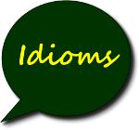

Page **70** of **75**

**VERBAL ABILITY**



**HSEM2BTECHSTANDARDVA1119**

**Definition:**

An **idiom** (also called **idiomatic expression**) is an expression, word, or phrase that has a figurative meaning conventionally understood by native speakers. This meaning is different from the literal meaning of the idiom's individual elements. In other words, idioms don't mean exactly what the words say. They have, however, hidden meaning.

**Examples**

* "Kick the bucket"
* "Spill the beans"

**Idiom**: A common expression understood figuratively, as the literal definition makes no sense. The meaning of theseexpressions is different from the literal meaning or definition of the words of which they are made. Their meanings are however used figuratively. They mean respectively:



* "to die "
* "Disclose a secret “

Idioms do not convey the exact meaning of the words but are an expression of a hidden meaning.

**Above Water**

* **Meaning**: Not in extreme difficulty. Especially said of finances.
* **Example**:*We’re**not rich, but**we’re**keeping our heads* ***above water****.*

**Come Out in the Wash**

* **Meaning**: To be resolved with no lasting negative effect
* **Example**:*Right now it seems as though you have a lot of problems, but**don’t**worry**–**it will all* ***come out in the* *wash****.*

Note: This is used most often in the construction “it will all come out in the wash.” **Cut Corners**

* **Meaning**: Economize by reducing quality; take shortcuts
* **Example**:*Let’s**not* ***cut corners*** *on the roofing materials**–**with the rainstorms around here,**we’d**regret it later.*

**(The) Last Straw**

* **Meaning**: A problem or insult that finally demands a response
* **Example**:*It’s**always annoying when Rudy brings food to his office, but today he brought a durian.**That’s**the* ***last* *straw*** *– I’m**going to complain to the boss.*



Page **71** of **75**

**VERBAL ABILITY**

**Body Part Idioms**

* Cross your fingers – For good luck.
* Fell on deaf ears – People wouldn't listen to something.
* Get cold feet – Be nervous.
* Giving the cold shoulder – Ignore someone.
* Have a change of heart – Changed your mind.
* I'm all ears – You have my full attention.
* It cost an arm and a leg – It was expensive.

**Everyday Idioms**



* A grey area – Something unclear
* A rip-off – Too expensive
* Add fuel to the fire – To add more to an existing problem
* As easy as ABC – Something is very easy
* Call it a day – Time to quit
* Cool as a cucumber – To be very calm under stress
* Draw a blank – Can’t remember
* Get a kick out of it – Really enjoy/like something
* Get your act together – Behave properly
* Give it a shot – To try to do something
* Have mixed feelings – Be unsure of how you feel
* Have second thoughts – Have doubts
* In the same boat – Be in the same situation
* It’s in the bag – It’s a certainty
* Out of the blue – With no warning
* Pass with flying colors – To succeed at something easily
* Piece of cake – Something very easy
* Read between the lines – Find the hidden meaning
* Second to none – The best
* The icing on the cake – Something additional that turns good into great

**Animal Idioms**

* A bull in a china shop - Someone who is very clumsy
* Birdbrain - Someone who is not very smart
* Busy as a bee – To be very active and working hard at something
* Cat got your tongue? - Why aren’t you talking?
* Cry crocodile tears - To pretend to be upset
* Curiosity killed the cat - Asking too many questions may get you in trouble
* Different kettle of fish - Something completely different
* Doggy bag - A bag to take home leftovers from a restaurant



**HSEM2BTECHSTANDARDVA1119**



Page **72** of **75**

**VERBAL ABILITY**



**HSEM2BTECHSTANDARDVA1119**

* Fish out of water - Being somewhere you don’t belong
* Get off your high horse - Quit thinking you are better than others
* Hold your horses - Wait a minute
* Horse of a different color - Something that is quite different, a separate issue
* Let the cat out of the bag - Tell a secret
* Make a mountain out of a molehill - Make something unimportant into a big deal
* Night owl - Someone who stays up late
* Stir a hornet's nest – To cause a lot of trouble
* When pigs fly - To say something is impossible
* Wolf in sheep’s clothing - A person who pretends to be nice but is not
* You can't teach an old dog new tricks - It’s harder for older people to learn new things



**EXERCISE 1**

1. At one's wit's end

(a) Perplexed (b) Clear Up (c) Explain (d) Enlighten

1. At one's fingertips

(a) To take revenge (b) Matter of shame (c) Complete knowledge (d) None of these

1. At the spur of the moment

(a) Difficult Moment (b) Without Delay (c) Great Moment (d) Very Slow

|  |  |  |
| --- | --- | --- |
| 4. | All in all |  |
|  | (a) Every person | (b) Particular thing same in all |
|  | (c) Call all at once | (d) Most important |

1. Apple Pie Order

|  |  |  |  |  |
| --- | --- | --- | --- | --- |
|  | (a) In random order |  | (b) Related to fruits packing |  |
|  | (c) Related to dry fruit packing | | (d) In perfect order |  |
| 6. | At close quarters |  |  |  |
|  | (a) close examinations | (b) live near to each other | (c) live far to each other | (d) in love |
| 7. | Above board |  |  |  |
|  | (a) boasting person |  | (b) honest and straightforward | |
|  | (c) a man with arrogance |  | (d) a dishonest person |  |

1. As fit as a fiddle

|  |  |  |  |  |
| --- | --- | --- | --- | --- |
|  | (a) Very weak |  | (b) Recovering from illness |  |
|  | (c) Looks fit but not fit actually | | (d) None of these |  |
| 9. | At logger heads |  |  |  |
|  | (a) In difficulty | (b) to be at strife | (c) very happy together | (d) None of these |
| 10. | An apple of discord |  |  |  |
|  | (a) cause of wealth | (b) cause of illness | (c) cause of happiness | (d) cause of quarrel |



Page **73** of **75**

**VERBAL ABILITY**



**HSEM2BTECHSTANDARDVA1119**

1. At a loss

(a) at a business loss (b) at a relation loss (c) to be unable to decide (d) None of these

1. At dagger's drawn

(a) to have bitter enmity (b) to be very friendly (c) to be unknown (d) to be very familiar

1. Bone of contention

(a) Point of an argument (b) Worthless (c) Without any hesitation (d) To succeed

1. Talk through one's hat

(a) Talk good points (b) To talk secretly (c) Talk positively (d) Talk nonsense

|  |  |  |
| --- | --- | --- |
| 15. | Bite the bullet |  |
|  | (a) To get someone drunk | (b) Talking nonsense |
|  | (c) Fight with others | (d) Face unpleasant situation |
| 16. | Hand over fist |  |
|  | (a) Get panic | (b) State of high alert |
|  | (c) Quickly and continuously | (d) Get comfortable |
| 17. | Black Sheep |  |
|  | (a) A costly item | (b) A dark shiny object |
|  | (c) An unworthy person in a family or group | (d) A funny man |
| 18. | Spill the beans |  |
|  | (a) Arrive just on time | (b) Feel sick |
|  | (c) To screw up | (d) Reveal someone's secret |
| 19. | To fly off the handle |  |
|  | (a) To be confused | (b) Making friendship |
|  | (c) Punish someone | (d) To lose one's temper |
| 20. | Make a name for oneself |  |
|  | (a) To gain fame | (b) To disturb others |
|  | (c) To help others | (d) Escape from trouble |



[

**Some more Common Idioms List**

|  |  |  |  |  |  |  |  |  |  |  |  |  |  |  |  |  |
| --- | --- | --- | --- | --- | --- | --- | --- | --- | --- | --- | --- | --- | --- | --- | --- | --- |
|  |  |  |  |  |  |  |  |  |  |  |  |  |  |  |  |  |
| **Common Idioms** | **Meaning** |  |
|  | |  |  |  |  |  |  |  |  | |  |  |  |  |  |  |
|  |  |  |  |  |  |  |  |  |  |  |  |  |  |  |  |  |
| It cost me **an arm and a leg** to take my trip to Australia. | | | | | |  |  | *Very expensive* | |  |
|  | |  |  |  |  | |  |  |  | | |  |  |  |  |  |
|  |  |  |  |  |  | |  |  |  |  |  |  |  |  |  |  |
| I was **over the moon** when he asked me to marry him. | | | | |  |  | *Extremely pleased or happy* | | | |  |
|  | |  |  |  | | |  | |  | | |  | |  |  |  |
|  |  |  |  |  |  |  |  |  |  |  |  |  |  |  |  |  |
| You are taking your IELTS test next week?? Aren’t | | | | | | | you | *Doing or starting something too early* | | | | |  |
|  | |  |  |  | | |  |  |  |  |  |  |  |  |  |  |
| **jumping the gun**.You’veonly just started studying. | | | |  |  |  |  |  |  |  |  |  |  |
|  | |  |  | | | |  |  |  | | |  | | |  |  |
|  |  |  |  | | | |  |  |  |  |  |  | | |  |  |
| He comes round to see me **once in a blue moon**. | | |  |  | *Happening very rarely* | | |  |
|  | |  | | | | |  |  |  | | | | | |  |  |
|  |  |  | | | | |  |  |  |  |  |  |  |  |  |  |
| He’s got a **chip on his shoulder**. | |  |  | *Feeling inferior or having a grievance about something* | | | | | |  |
|  |  |  |  |  |  |  |  |  |  |  |  |  |  |  |  |  |

I reckon getting a band 7 in IELTS will be a **piece of cake**! I’m *Very easy* very good at English.

The money sent by comic relief to help poverty in Africa is *A very small part of something much bigger*



Page **74** of **75**

**VERBAL ABILITY**



**HSEM2BTECHSTANDARDVA1119**

just **a drop in the ocean**. They need far more than this.

Getting a low score the first time I took IELTS was **a blessing** *Something positive that* *isn’t* *recognized until later* **in disguise**. It forced me to study extremely hard so I got a

much better score the next time.

|  |  |
| --- | --- |
| We have to actually do something about global warming. *It’s* *better to actually do something rather than just* | |
| **Actions speak louder than words**. | *talking about it* |

1. bumped into Jenny in town the other day. **It's a small** *Meeting someone you would not have expected to* **world**.

|  |  |  |  |  |  |  |  |  |  |  |  |  |  |  |  |  |  |  |  |  |  |  |  |  |  |  |  |  |
| --- | --- | --- | --- | --- | --- | --- | --- | --- | --- | --- | --- | --- | --- | --- | --- | --- | --- | --- | --- | --- | --- | --- | --- | --- | --- | --- | --- | --- |
|  |  |  |  |  |  |  |  |  |  |  |  |  |  |  |  |  |  |  |  |  |  |  |  |  |  |  |  |  |
| **Common Idioms** | | | **Meaning** | | |  |
|  |  |  | |  |  |  |  |  |  |  |  | |  |  | |  |  | |  |  |  |  |  |  |  |  |  |  |
|  |  |  |  |  |  |  |  |  |  |  |  |  |  |  |  |  |  |  |  |  |  |  |  |  |  |  |  |  |
| Oh well, I got 5.5 in IELTS again. **Back to the drawing** | | | | | | | | | | | | | *When an attempt to do something fails and it's time to* | | | | | | | | | | | | |  |
|  |  |  | |  |  |  |  |  |  |  |  |  |  |  |  |  |  | |  |  |  |  |  |  |  |  |  |  |
| **board**! | |  |  |  | *start all over again using different methods* | | | | | | |  |
|  |  | | |  |  |  |  |  |  |  |  | | |  | |  |  | |  |  |  | |  |  |  |  |  |  |
|  |  |  |  |  |  |  |  |  |  |  |  |  |  |  |  |  |  |  |  |  |  | |  |  |  |  |  |  |
| I hate my job so much I can’t bare going to work, but if I quit I | | | | | | | | | | | | | *Having two very bad choices.* | | | |  |
|  |  | | |  |  |  |  |  |  |  |  | | |  | |  |  | |  |  |  | |  |  |  |  |  |  |
| don’t think I can get another job. I’m really **stuck / caught** | | | | | | | | | | | | |  |  |  |  |  | | |  |  | |  |  |  |  |  |  |
| (note: stuck/caught can be omitted) | | | | | |  |
| **between a rock and a hard place**. | | | | | | | |  |  |  |  |  |  |  |  |  |  |  |  |  |  |  |  |  |  |  |  |  |
|  |  | | |  |  |  |  | |  |  |  | | |  | |  |  | | |  | | |  |  |  |  |  |  |
|  |  |  |  |  |  |  |  |  |  |  |  |  |  |  |  |  |  |  |  |  |  |  |  |  |  |  |  |  |
| I have to **bite my tongue** so I don’t say what I really think of | | | | | | | | | | | | | *Wanting to say something but stopping yourself.* | | | | | | | | | | |  |
|  |  | | |  |  |  |  | |  |  |  |  |  |  |  |  |  |  |  |  |  |  |  |  |  |  |  |  |
| him! |  |  |  |  |  |  |  |  |  |  |  |  |  |  |  |  |  |
|  | | | |  |  |  |  | |  |  |  |  |  |  |  |  |  | | |  | | |  |  |  | |  |  |
|  |  |  |  |  |  |  |  |  |  |  |  |  |  |  |  |  |  |  |  |  |  |  |  |  |  |  |  |  |
| Come on, **cut to the chase**. We haven’t got all day! | | | | | | | | |  |  |  | *Leave out all the unnecessary details and just get to the* | | | | | | | | | | | | |  |
|  |  |  |  |  |  |  |  |  |  |  |  |  |  |  |  |  |  | | |  | | |  |  |  | |  |  |
|  |  |  |  |  |  |  |  |  |  |  |  |  |  |  | *point* |  |
|  | | | |  |  |  |  | | |  |  | | |  | | |  | | |  | | |  |  |  | |  |  |
|  |  |  |  |  |  |  |  |  |  |  |  |  |  |  |  |  |  |  |  |  |  |  |  |  |  | |  |  |
| Are you putting all of your savings into that company? Don’t | | | | | | | | | | | | | *Putting all of ones resources into one possibility* | | | | | | | | | |  |
|  | | | |  |  |  |  | | |  |  |  |  |  |  |  |  |  |  |  |  |  |  |  |  |  |  |  |
| **put all your eggs in one basket**. | | | | | |  |  |  |  |  |  |  |  |  |  |  |  |  |  |  |  |  |
|  | | | |  |  | |  | | |  |  |  |  |  |  | |  | | |  | | |  |  | | |  |  |
|  |  |  |  |  |  |  |  |  |  |  |  |  |  |  |  |  |  |  |  |  |  |  |  |  |  |  |  |  |
| Try not to worry about it. **Every cloud has a silver lining**. | | | | | | | | | | |  |  |  | *Believing that every bad situation has a positive side /* | | | | | | | | | | | | |  |
|  |  |  |  |  |  |  |  |  |  |  |  |  |  |  |  | |  | | |  | | |  |  | | |  |  |
|  |  |  |  |  |  |  |  |  |  |  |  |  |  |  | *eventually leads to something good* | | | | |  |
|  | | | |  |  | |  | | |  | |  | |  | | |  | | | | | |  |  | | |  |  |
|  |  |  |  |  |  |  |  |  |  |  |  |  |  |  |  |  |  |  |  |  |  |  |  |  | | |  |  |
| It was difficult when I moved to another country but | | | | | | | | | | | | I | *To become comfortable in what you are doing* | | | | | | | | |  |
|  | | | |  |  | |  | | |  | |  |  |  |  |  |  |  |  |  |  |  |  |  |  |  |  |  |
| eventually **found my feet**. | | | | |  |  |  |  |  |  |  |  |  |  |  |  |  |  |  |  |  |
|  | | | |  | | |  | | |  | | | |  | | |  | | | | | |  | | | |  |  |
|  |  |  |  |  |  |  |  |  |  |  |  |  |  |  |  |  |  |  |  |  |  |  |  |  |  |  |  |  |
| My parents are very **fixed in their ways**. They won’t start | | | | | | | | | | | | | *Not wanting to change from the normal ways of doing* | | | | | | | | | | | | |  |
|  | | | |  | | |  | | |  | |  |  |  |  | |  | | | | | |  | | | |  |  |
| using the internet. | | | |  |  |  | *things* | |  |
|  | | | | | | |  | | |  | | | |  | | | | | | | | |  | | | |  |  |
|  |  |  |  |  |  |  |  |  |  |  |  |  |  |  |  |  |  |  |  |  |  |  |  | | | |  |  |
| I think he **got up on the wrong side of the bed this** | | | | | | | | | | | | | *To refer to someone who is having a bad day* | | | | | | | |  |
|  | | | | | | |  | | |  | |  |  |  |  |  |  |  |  |  |  |  |  |  |  |  |  |  |
| **morning**. He is in a terrible mood. | | | | | | |  |  |  |  |  |  |  |  |  |  |  |  |  |  |  |  |  |
|  | | | | | | | | | |  | |  |  |  |  | | | | | | | | | | | |  |  |
| My mother will always **go the extra mile** to help people. | | | | | | | | | |  | |  |  |  | *Doing much more than is required when doing something* | | | | | | | | | | | |  |  |
|  |  |  |  |  |  |  |  |  |  |  |  |  |  |  |  |  |  |  |  |  |  |  |  |  |  |  |  |  |



HETERONYMS

Page **87** of **87**

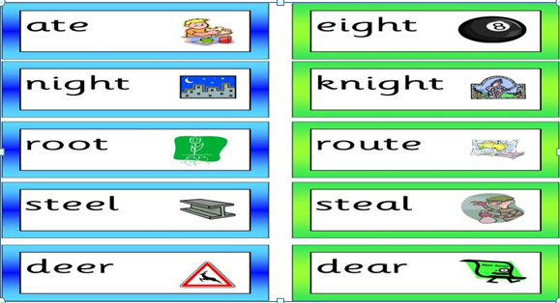

HOMOPHONES

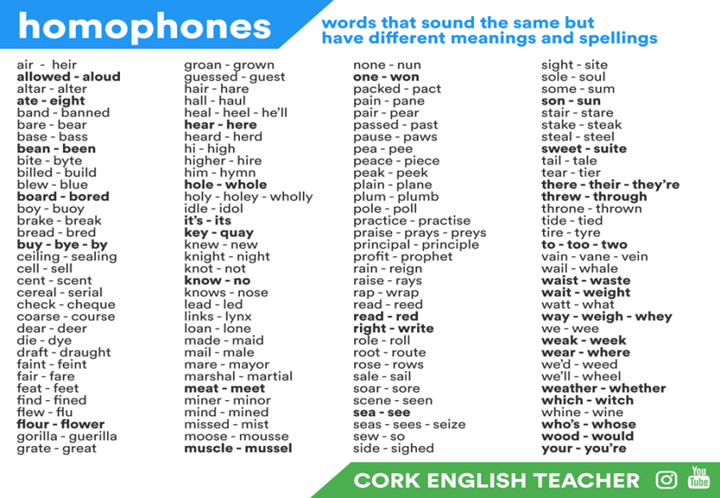

HOMONYMS

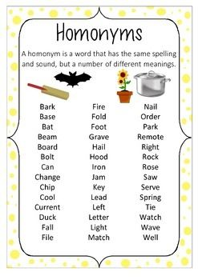

Page **75** of **75**